CHATBOT AZ-3016

"So, this whole thing is a chatbot project I did for my SkillUpOnline Module AZ-3016, which is all about Microsoft Azure Services. The big goal was to get the chatbot up and running, or even just access it, right from my computer's terminal (that's like using VS Code) by hooking it up with an Azure Functions app. Now, I hit some technical snags and couldn't quite finish everything, which was a bit of a bummer. But even with those limitations, I still managed to get the Functions app deployed in Azure and even in VS Code! So, I definitely made some great progress!"

Problem Statement :

Project Title: Simple FAQ Copilot (CLI Version)

Project Overview
The Simple FAQ Copilot is an AI-powered tool that answers frequently asked questions based on a predefined dataset. Users will interact with the copilot through a command-line interface.

Project Components
1. Define Requirements
Target Audience: Users seeking quick answers to common questions.
Features:
  - Users can type questions and receive answers.
  - Ability to suggest new questions for future training (optional).
  - User feedback mechanism for improving accuracy (optional).
2. Technology Stack
    - Programming Language: Python (or any language of your choice).
    - Backend: Azure Functions (for serverless architecture).
    - AI Model: Azure AI Studio for training the custom FAQ model.
    - Database: Optional for storing user feedback.

Implementation Steps
Step 1: Set Up Azure AI Studio
- Create an Azure Account:
- Sign up for an Azure account if you don't have one.
- Navigate to Azure AI Studio:
- Go to Azure AI Studio and create a new project for your FAQ Copilot.
- Gather Training Data:
- Create a dataset of frequently asked questions and their corresponding answers. For example:
Question | Answer
What are your operating hours? | We are open from 9 AM to 5 PM, Monday to Friday.
How can I contact support? | You can reach us at support@example.com.
What is your return policy? | You can return items within 30 days of purchase.
- Train the Model:
- Use the dataset to train your FAQ model in Azure AI Studio.
- Define the model parameters, such as language and context.
- Test the model to ensure it generates relevant answers.

Step 2: Build the Backend with Azure Functions
- Create an Azure Function:
- Set up an Azure Function that will serve as the backend API for your application.
- This function will accept user input (questions) and call the Azure AI model to get answers.

import azure.functions as func
import requests
import json

def main(req: func.HttpRequest) -> func.HttpResponse:
try:
req_body = req.get_json()
user_question = req_body.get('question')

# Call the Azure AI model
response = requests.post(
'YOUR_AZURE_AI_MODEL_ENDPOINT',
headers={'Authorization': 'Bearer YOUR_API_KEY'},
json={'input': user_question}
)
answer = response.json().get('answer')
return func.HttpResponse(json.dumps({'answer': answer}), status_code=200)

except ValueError:
return func.HttpResponse("Invalid input", status_code=400)

Step 3: Create the Command-Line Interface
- Create a Python Script:
Create a Python script (e.g., `faq_copilot.py`) that will serve as the command-line interface.
import requests
import json
def get_answer(question):
try:
response = requests.post(
'YOUR_AZURE_FUNCTION_URL',
headers={'Content-Type': 'application/json'},
json={'question': question}
)
if response.status_code == 200:
answer = response.json().get('answer')
return answer
else:
return "Error: Unable to get an answer."
except Exception as e:
return f"Error: {str(e)}"
def main():
print("Welcome to the Simple FAQ Copilot!")
print("Type 'exit' to quit.")
while True:
user_question = input("You: ")
if user_question.lower() == 'exit':
print("Goodbye!")
break
answer = get_answer(user_question)
print(f"Copilot: {answer}")
if __name__ == "__main__":
main()

Running the Project
- Install Required Libraries:
- Ensure you have the requests library installed. You can install it using pip:
pip install requests
Run the Script:
- Execute the Python script from the command line:
python faq_copilot.py

Interact with the Copilot:
- Type your questions in the command line and receive answers from

My Approach to the Solution:
Project Rundown
Alright, so even though I couldn't quite finish the whole project, I still got a ton of important stuff done and set up! My main goal was building this smart chatbot, and for that, I grabbed this cool HDFC Banking FAQs dataset from Kaggle -> link [ https://www.kaggle.com/datasets/abbbhishekkk/faq-datasets-for-chatbot-training ] for which the owner of the dataset is [“Owner”:” https://www.kaggle.com/abbbhishekkk” ] . The whole thing was totally adaptive, I hope, Just kept pushing forward, even when things got tough!
I. Getting My Data Ready!
- Setting Up My Spot: First off, I set up a special folder.
- Grabbing the Goods: Then, I got the HDFC Banking FAQ dataset from Kaggle. Picked it because it was perfect for my banking chatbot idea.
- File Format Swap! After downloading and unzipping it, turns out the raw data was just plain text but the content was json array. But I needed it in .json format for my azure openai tools, especially my vector databases. So, I had to convert it. This wasn't just a quick edit; it was like translating it into a language my tools could actually use! Super crucial!
II. Setting Up My Azure Cloud Stuff!
- Keeping It Local: Big rule I stuck to: all my Azure cloud stuff had to be in the same spot, geographically.
- Like, 'Sweden Central' was my chosen area. Why? Well, it just makes everything run way smoother and faster, cuts down on annoying lag, and helps with data rules (super important for banking!).
- Azure Portal Playtime: I hopped onto the Azure and whipped up a custom Resource Group. Yep, 'Sweden Central' was the home base again, keeping it consistent!
  - Next, I set up an Azure Storage Account. This is where all my project's persistent data would just hang out. I specifically used its 'Blob Storage' feature, which is great for unstructured files like my JSON data. Again, right there in the same Resource Group and region for top performance.
  - Inside that new Storage Account, I made a dedicated container. Kind of like a sub-folder in my storage. And guess what? I securely uploaded my .json dataset right into a folder in there. Now, all my other Azure services could totally get to that valuable data. Sweet!
III. Getting Azure OpenAI Ready!
- Firing Up OpenAI: Okay, big moves now! Next step was getting the Azure OpenAI Service resource deployed in Azure. I went with Azure OpenAI text embedding model to vectorize my Jason array data stored as a blob storage.
  - After that was set up, I bounced over to the AI Foundry.
  - And in there, I strategically deployed a Text Embedding model.
  - They take normal text and turn it into these super clever numbers (vectors) that actually capture what the text means.
  - This is key for smart, semantic search – meaning it finds stuff not just by keywords, but by truly understanding what your question means! I made sure it was linked to my Azure Storage Account so it could grab all the data for the embedding process.
IV. Setting Up Azure AI Search!
- Making My Data Super Searchable! My next big mission was setting up the Azure AI Search service. This thing is a total powerhouse for searching! It hooks up perfectly with those OpenAI text embeddings, giving you wicked fast and super relevant search results from your data.
  - I used its 'Import and vectorize data' feature. This whole process is pretty slick: it automatically pulls in the data from my Azure Blob Storage container, then uses the Text Embedding model to create those special numerical codes (vectors). Finally, it builds a powerful search index that's awesome for both regular keyword searches and those smart semantic ones. I carefully picked the right settings here to make sure the search was speedy and on point.
  - Super important: I double-checked all the extracted fields (like 'question' and 'answer') to make sure they were mapped correctly for the chatbot. Seriously vital for the bot finding the right info! Also, I set up semantic configurations for each data chunk. This just means I helped the search service really get the deep meaning of questions and documents. It leads to way better, super relevant search results, and I totally made sure everything was checked and configured for peak performance!
V. Deploying and Testing Our Chatbot!
- Building the Bot! Back in the AI Studio, I deployed the GPT-4o model – it's amazing for smart, relevant answers! This super advanced AI model was my top pick because it's really good at chatting, understands complex stuff, and just gives solid responses. Perfect for a fancy banking FAQ chatbot!
- Testing & Tweaking Time: Then, it was time to hit the Chat Playground. This is my dedicated spot to really put the chatbot through its paces, making sure it's intuitive and performs like a champ. Testing is absolutely crucial, you know, to make sure the bot actually answers user questions effectively and gracefully!
  - This serious testing involved trying it all sorts of test questions (just like real people would ask!). I also made small, iterative tweaks to its settings – like 'temperature' (which makes it more creative or random), 'top_p' (how diverse its responses are), and 'max_tokens' (how long its answers can be). This fine-tuning helps get the bot's output just right. Oh, and also the custom prompt I added! That's a super important little instruction manual that tells the AI how to act – like being a super helpful banking assistant – and how its answers should look. This step totally supercharges the user experience and keeps the bot on the straight and narrow for the project's goals!
VI. Getting Our App Running Locally and Serverless!
- Saving My Important Stuff: For safekeeping (and for any future fixes), I made sure to securely save all the crucial bits like endpoints and API keys in a safe spot. Gotta keep that security tight and make it easy to grab them later!
- VS Code Prep: I kicked off the development in Visual Studio Code (VS Code) – it's just the best! I installed the Azure Functions extension, which made working with serverless functions a total breeze. And I got my Azure account connected right in VS Code, so everything just talked to each other smoothly.
- Azure Function App Go! Then, I deployed the Function App through the Azure Portal. Function Apps are awesome because they're serverless, meaning you just write code and Azure handles all the boring server stuff for you! And yep, it was deployed in the same region and Resource Group as everything else – consistent architecture!
  - Once it was out there, I jumped back to VS Code and started a new project using the Function App template. This just gives you a head start with the right project structure. Then, I smoothly connected this local project to the Function App I'd just deployed in the cloud, setting up a direct line for future code pushes.
- Local Test Drive! Before sending it fully to the cloud, I did some serious testing of the Function App right there in VS Code. This was super important! I used those API keys and endpoints to pretend I was a real user, making sure everything worked exactly as it should in my own little test zone.
  - This testing even involved writing a simple Python script that would call the Function's web address (URL) and use the API key. This script was my ultimate end-to-end test, confirming the API calls went through, responses came back right, and the whole serverless setup was humming along perfectly. It totally showed my app was ready to go, all serverless and prepped for the big leagues!

Personal Solution

Getting Data Ready.
- Step 1 :
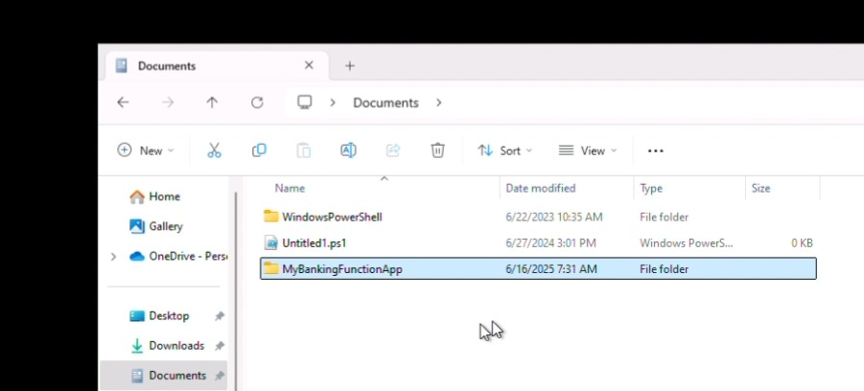
Create a new empty directory “MyBankingFunctionApp”.

- Step 2 :
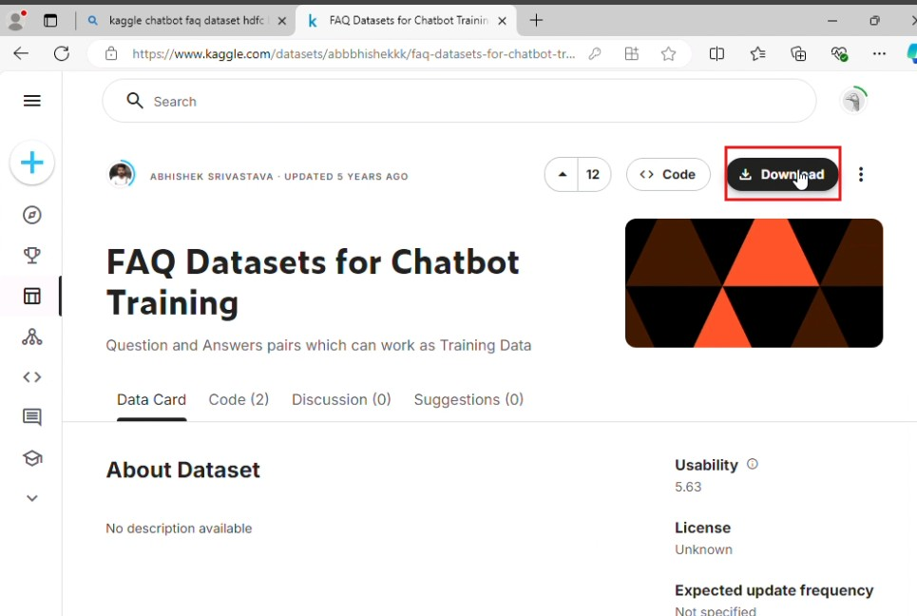
Goto Kaggle and download the data

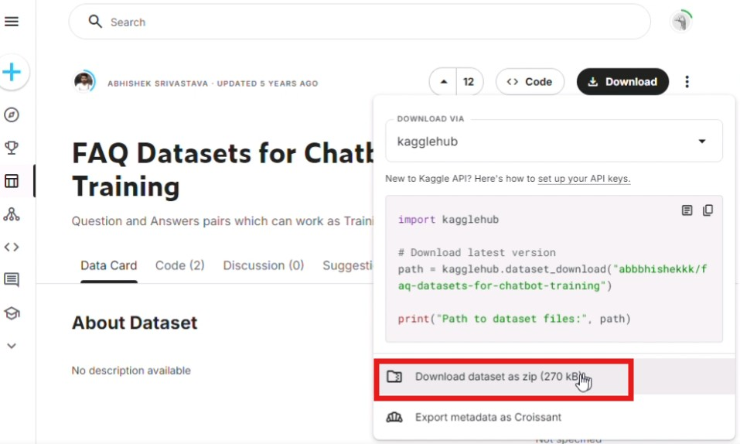

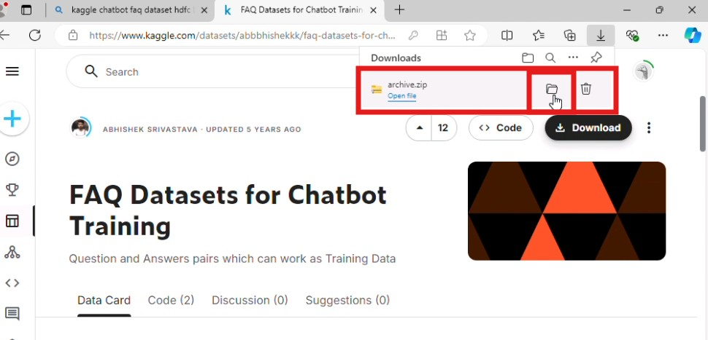

- Step 3 :
Unzip the data to the main to be function app folder
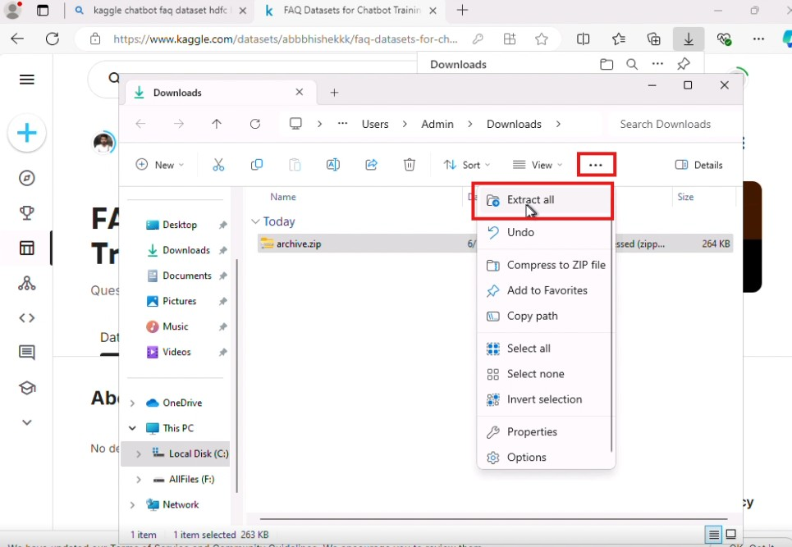

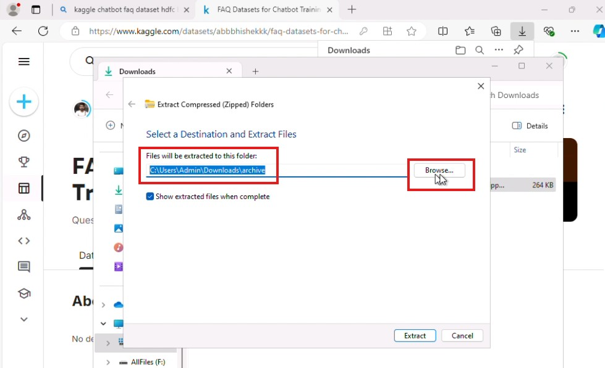

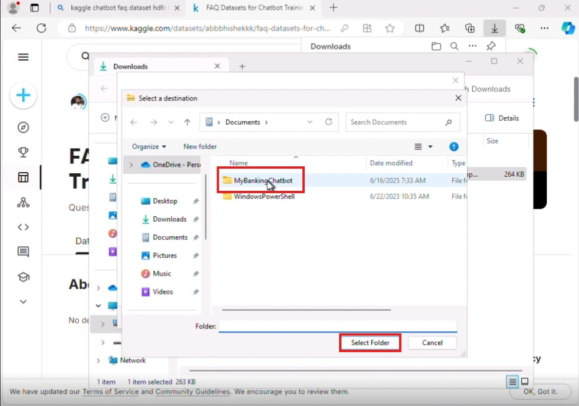

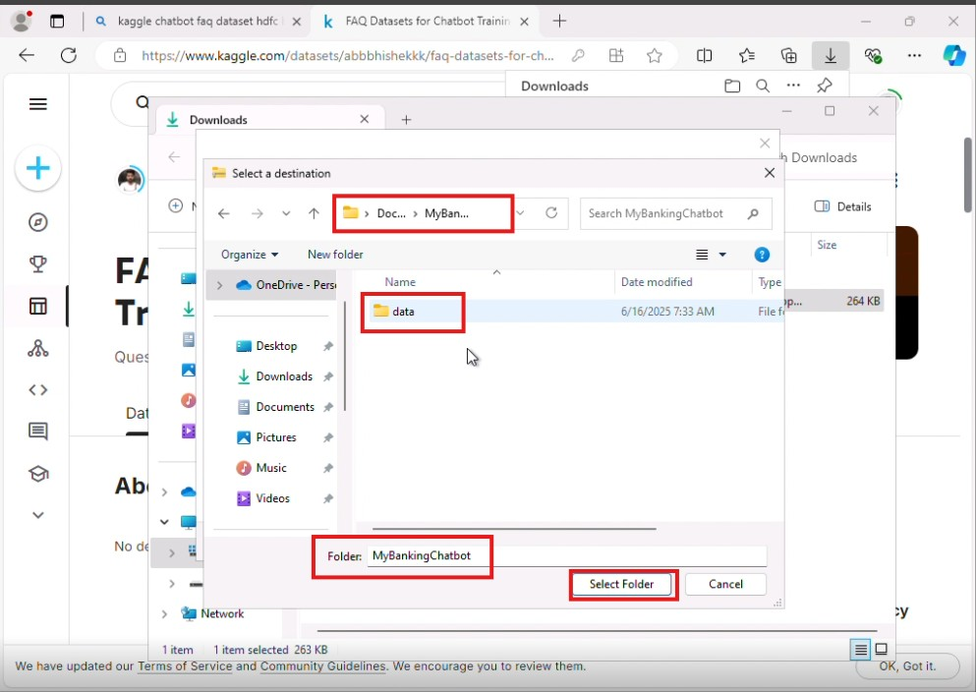

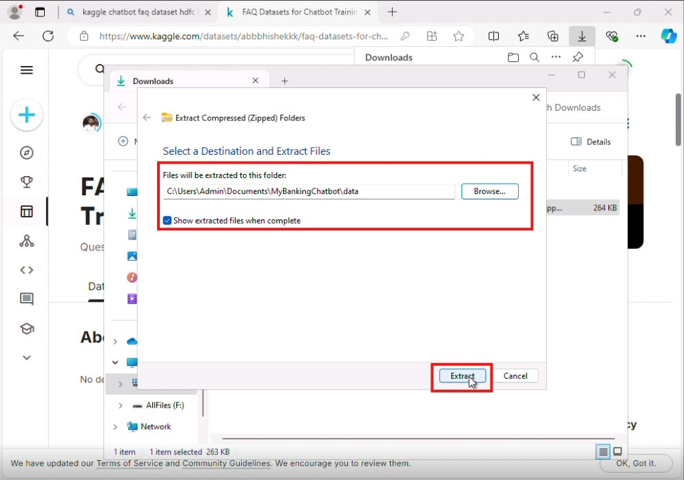

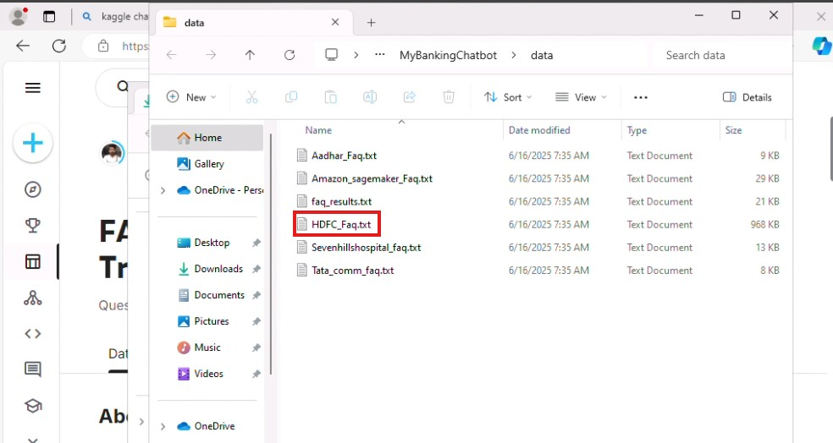

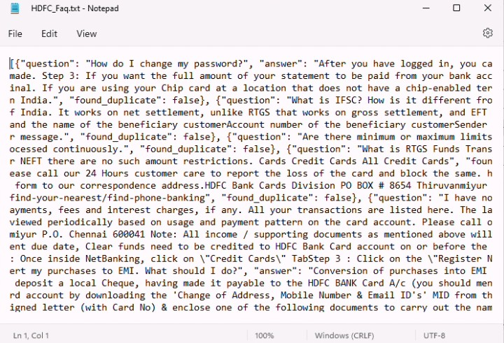

- Step 4 :
Change the ‘.txt’ to ‘.json’
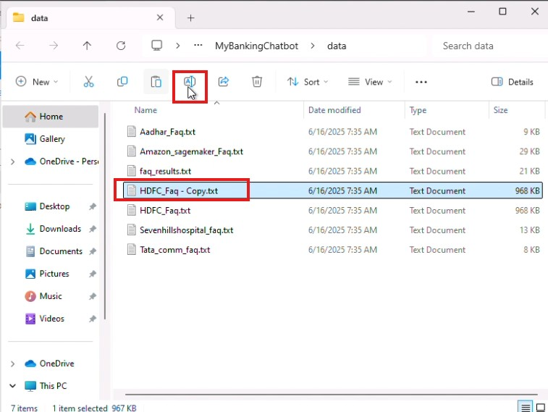

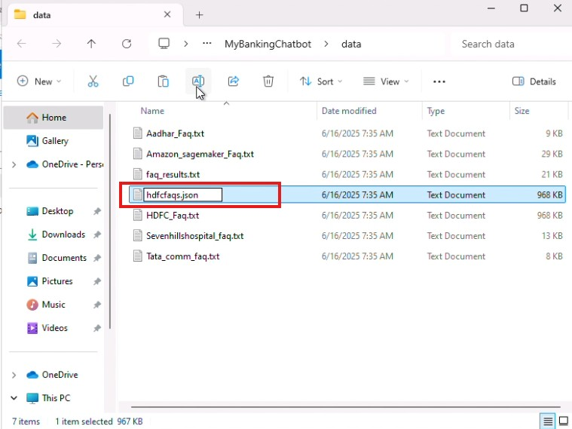

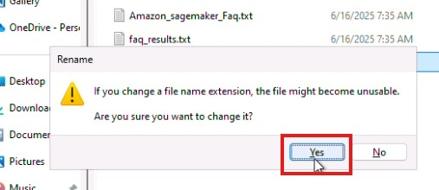

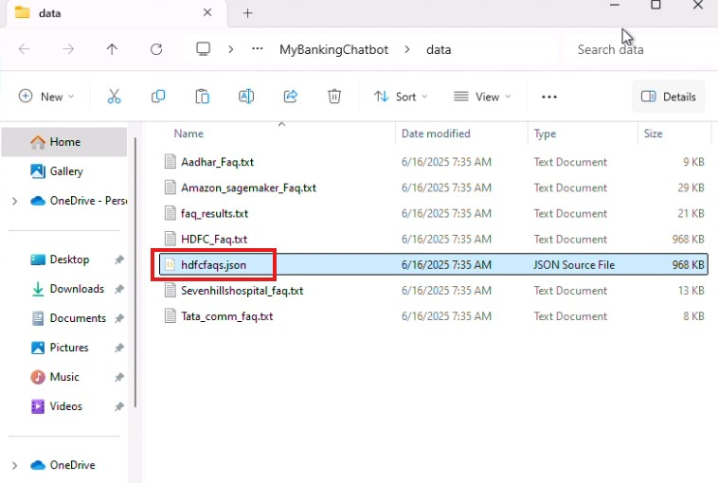

Setting azure Resources.

- Step 1 : Deploy the Resource Group from the available subscription.
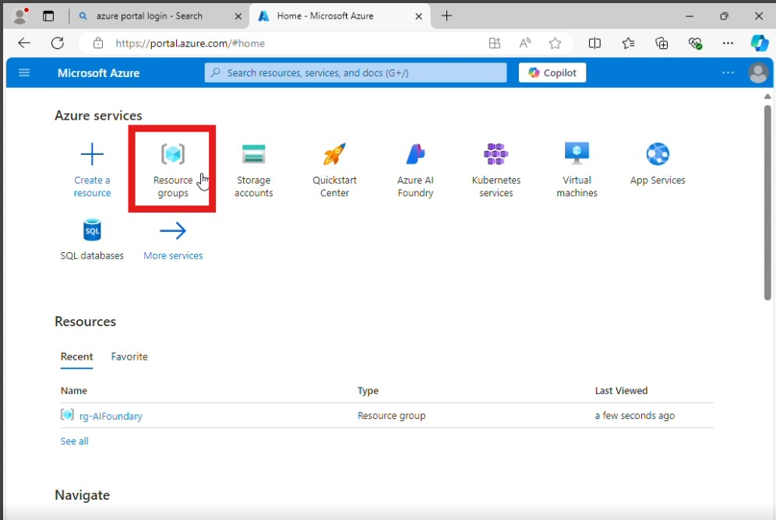

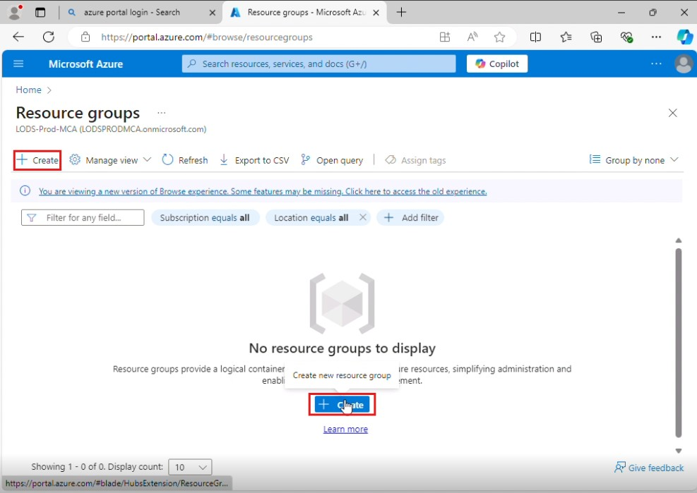

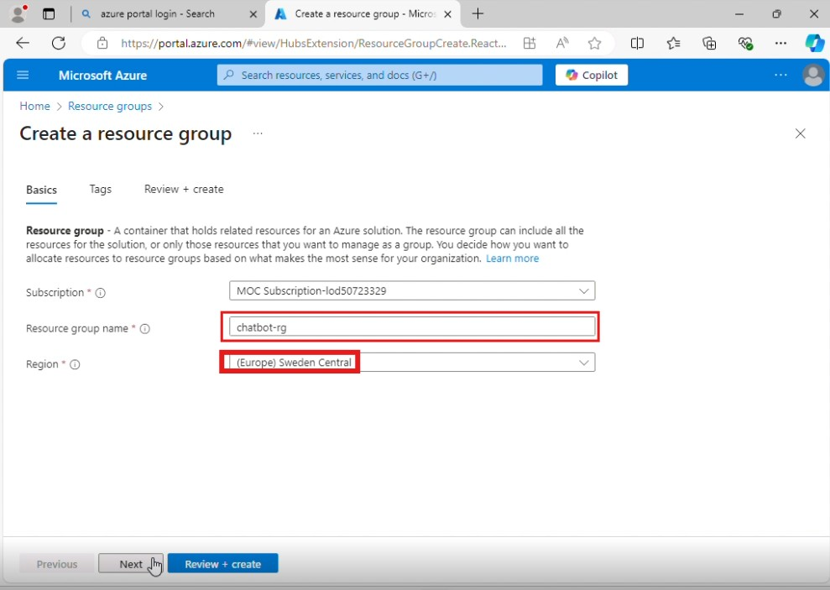

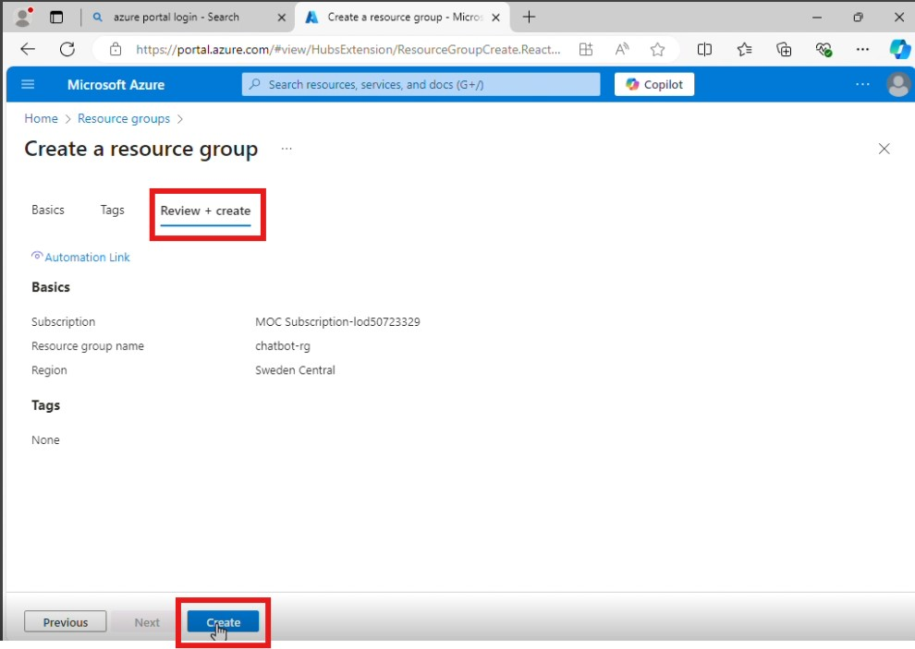

- Step 2 : Deploying the Storage Account Resources
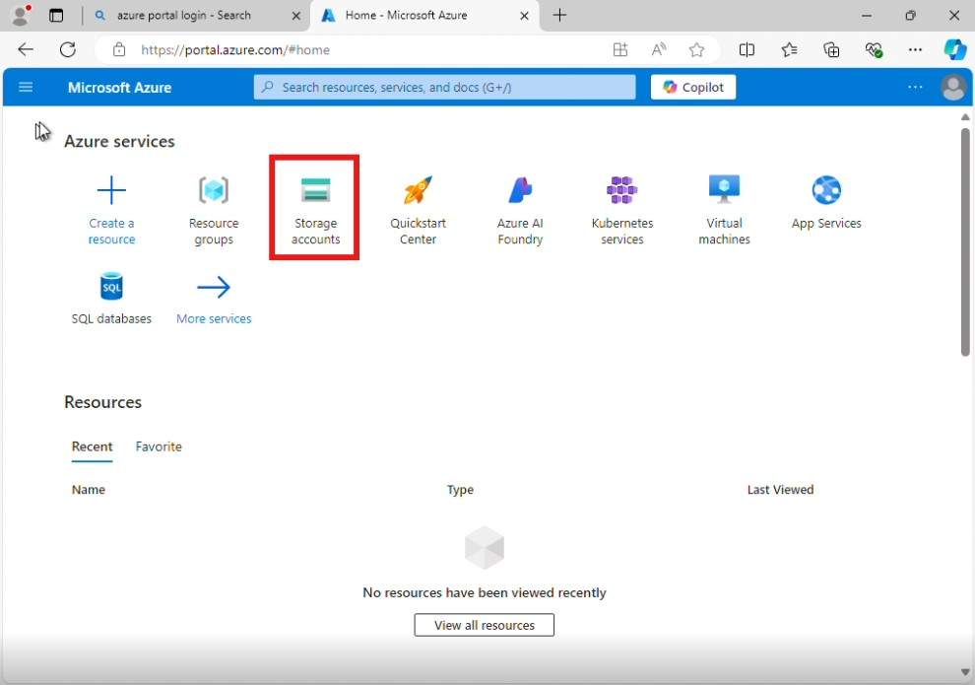

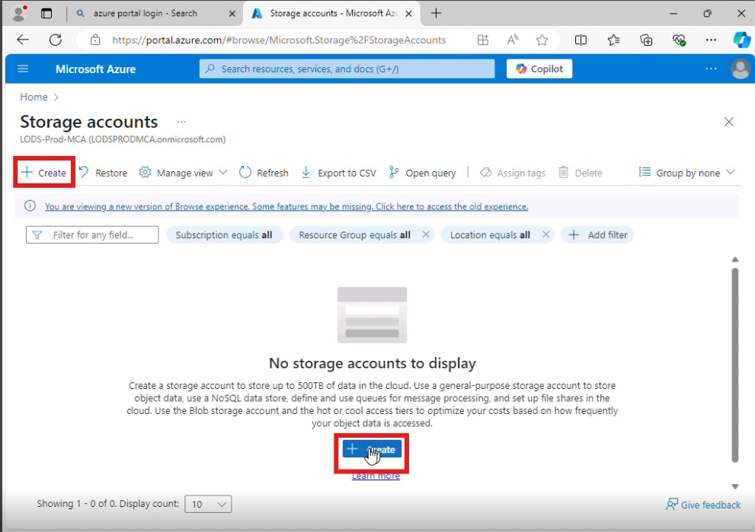
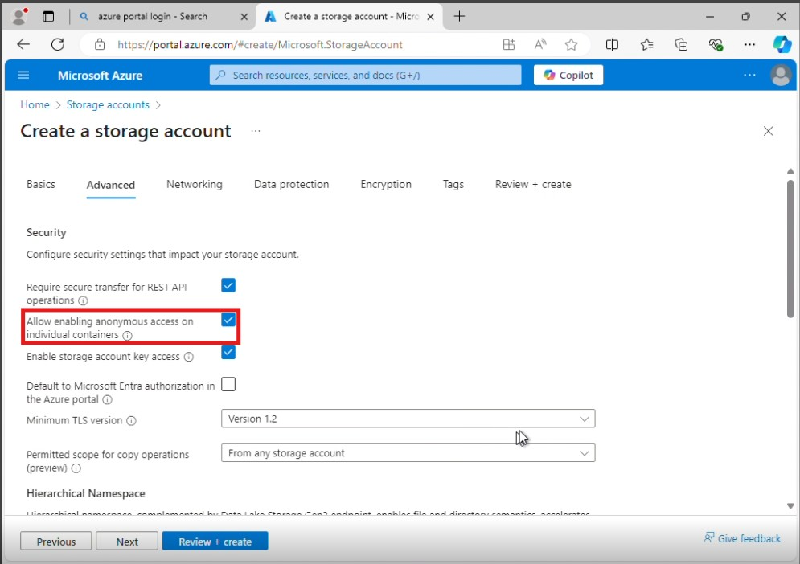
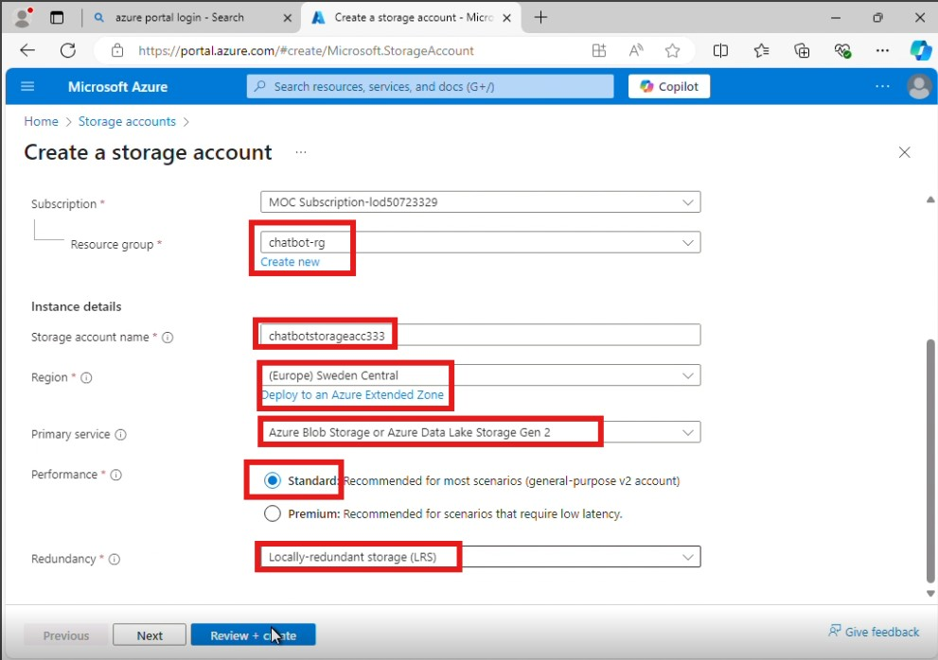
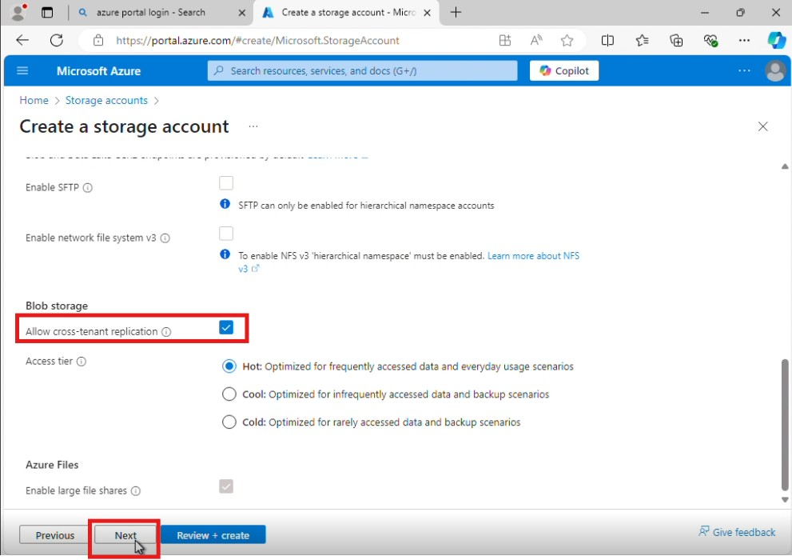

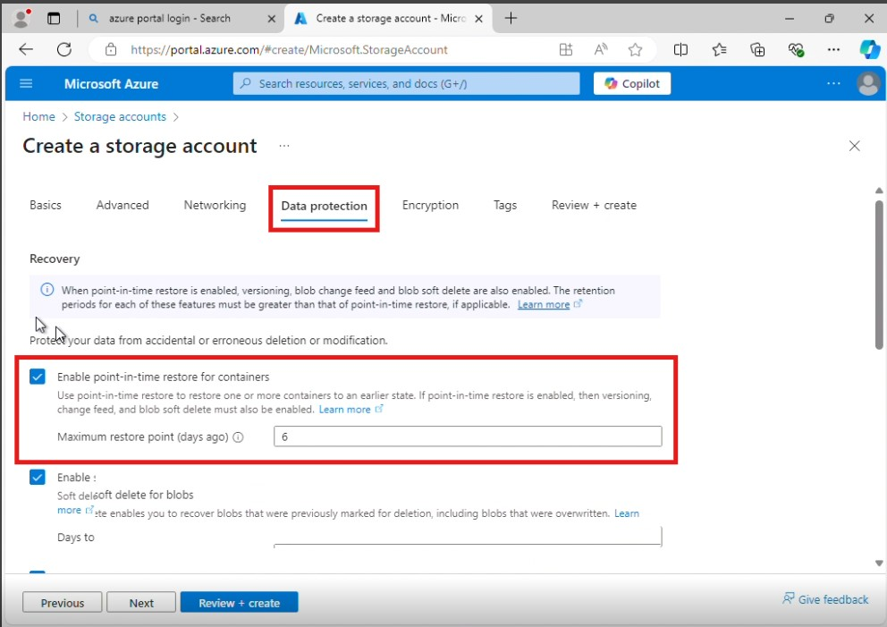

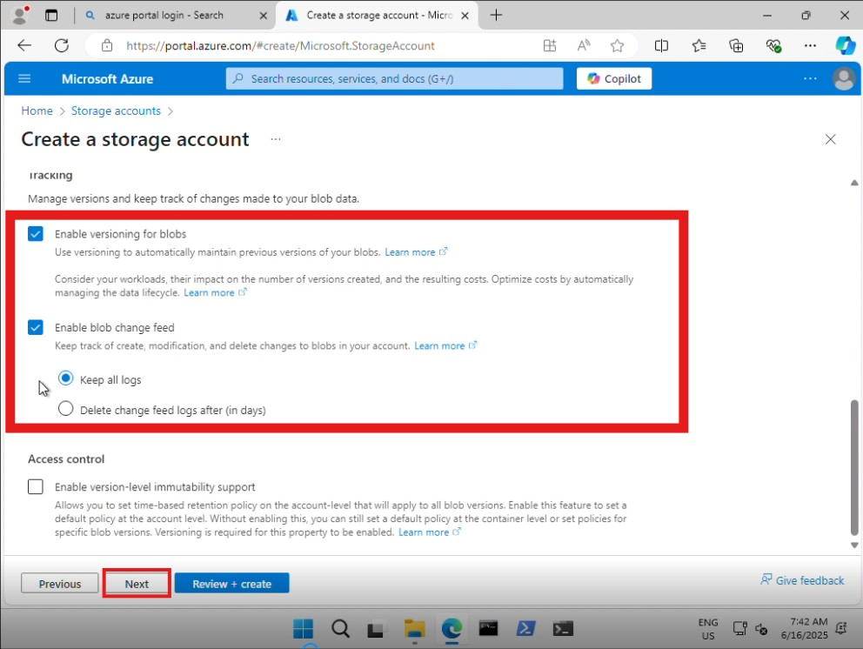

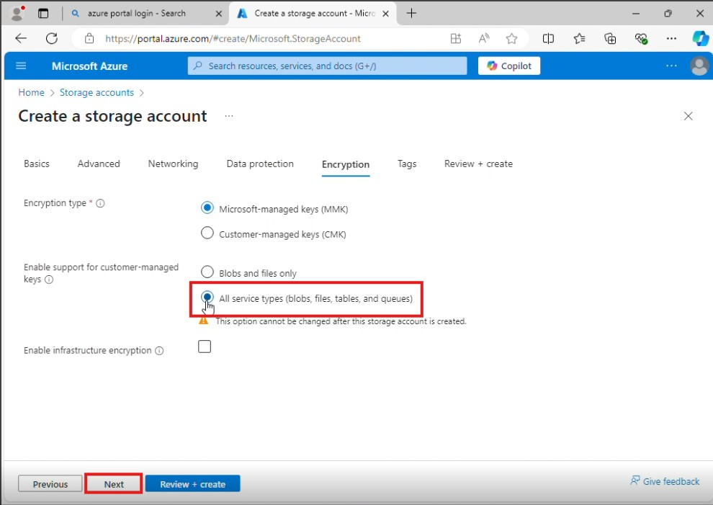

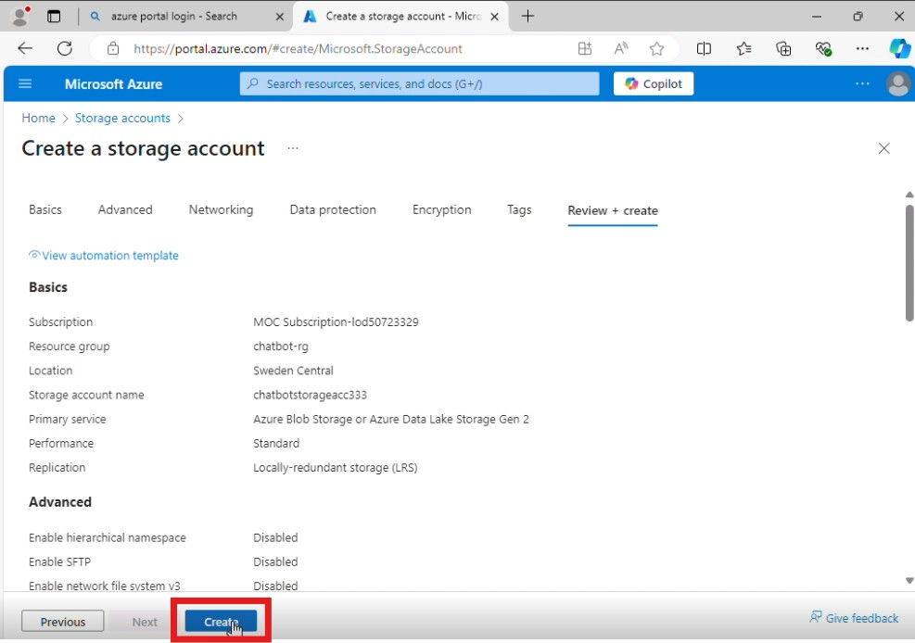

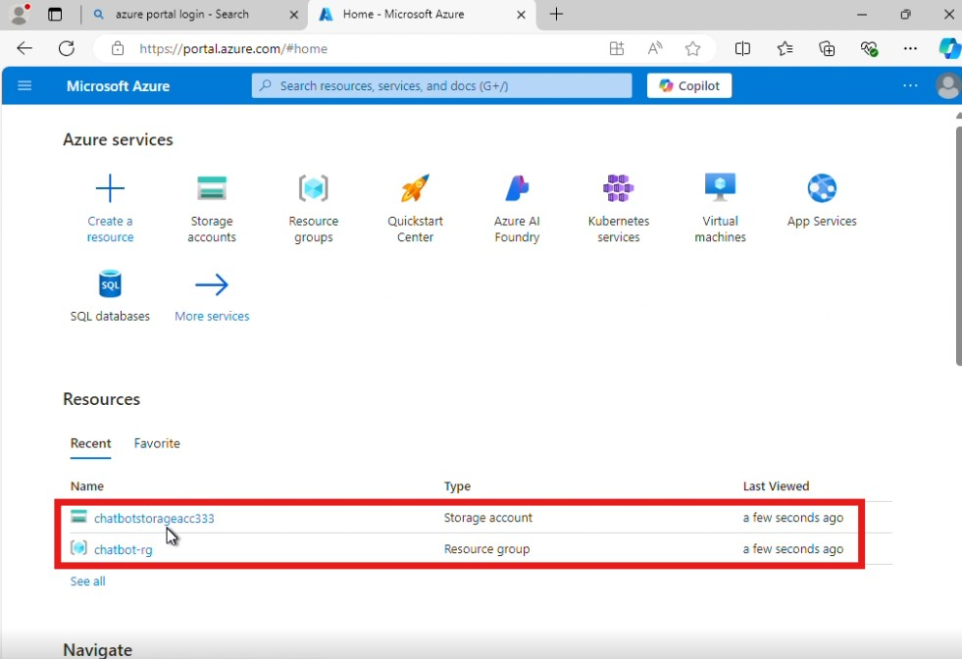

- Step 3 : Uploading the json file into the storage container.
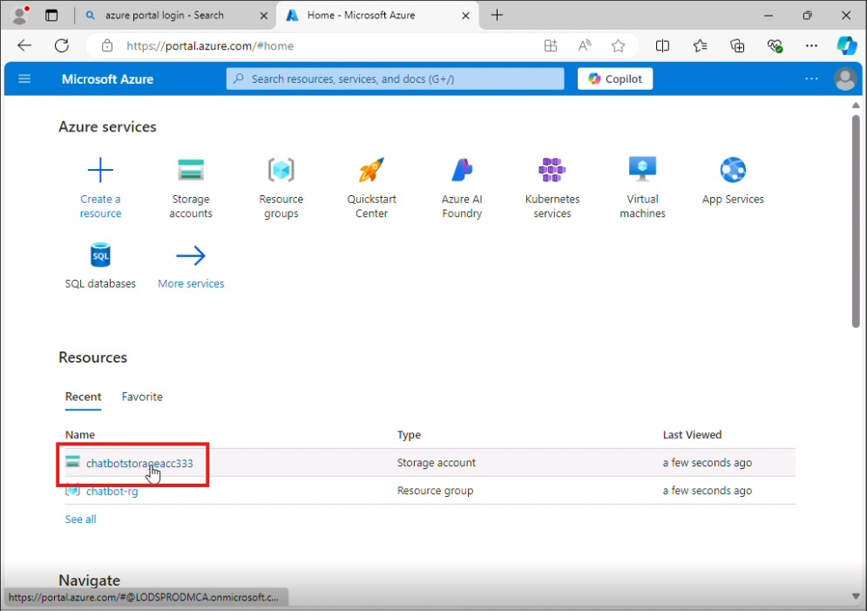

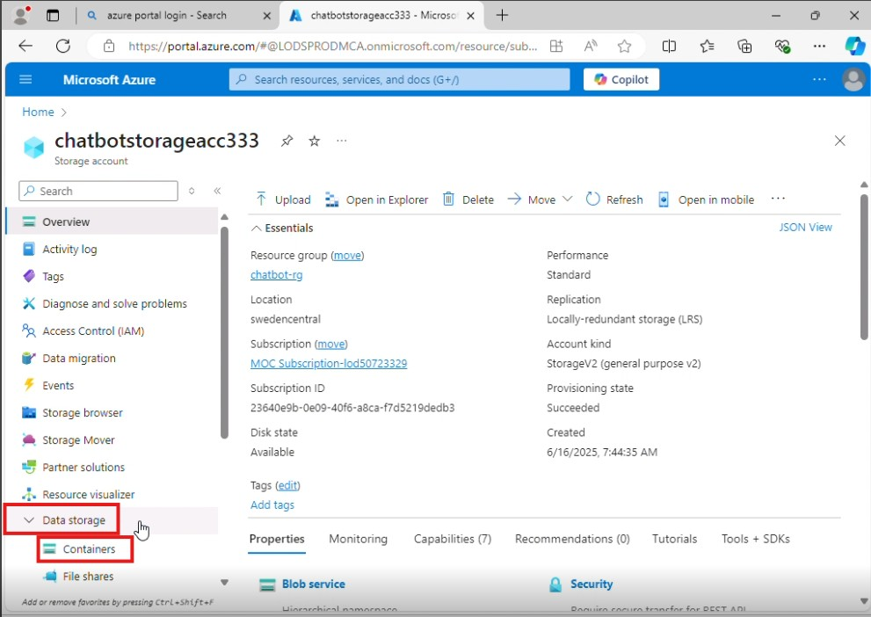

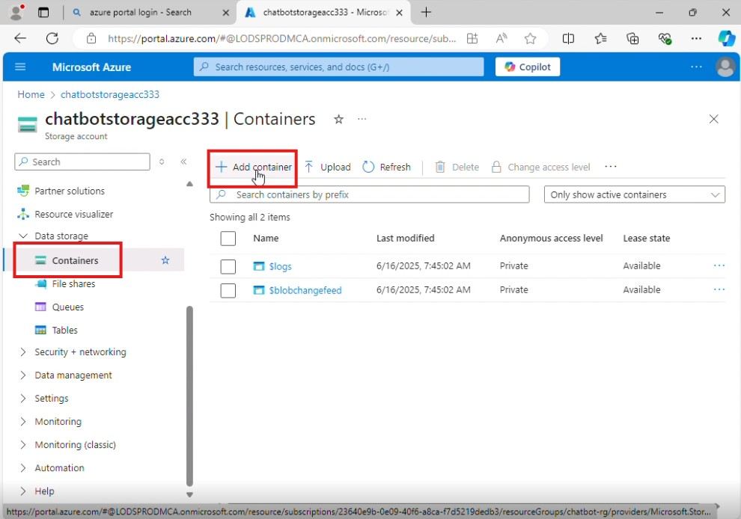

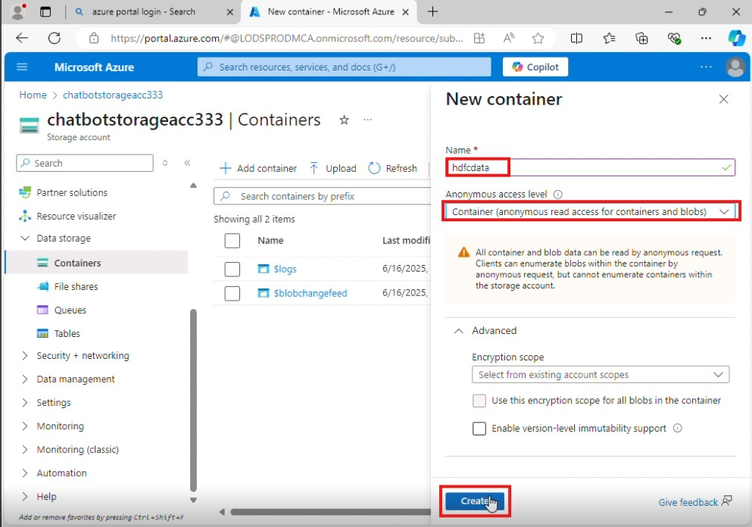

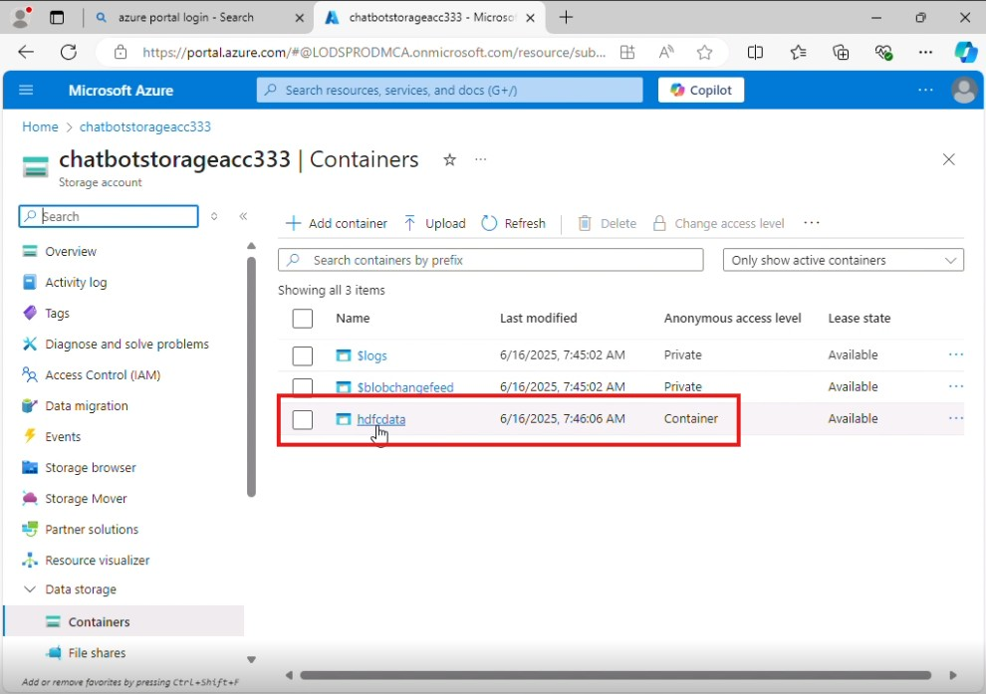

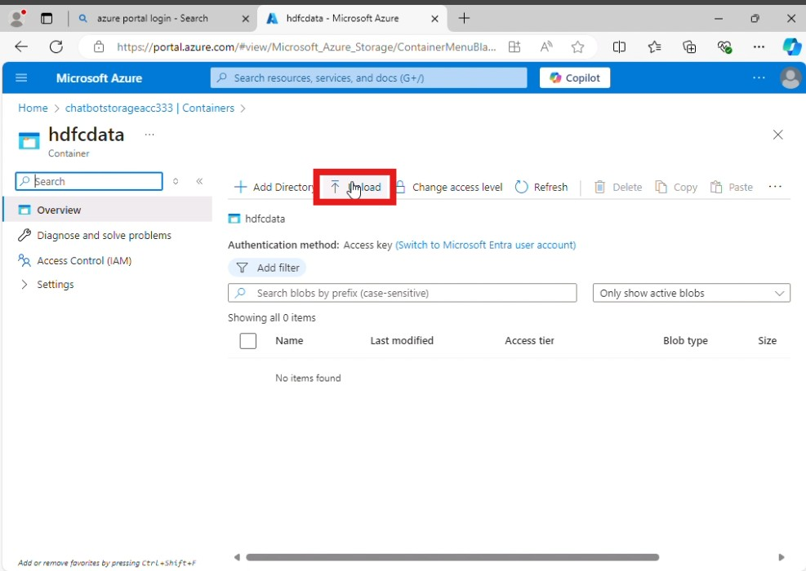

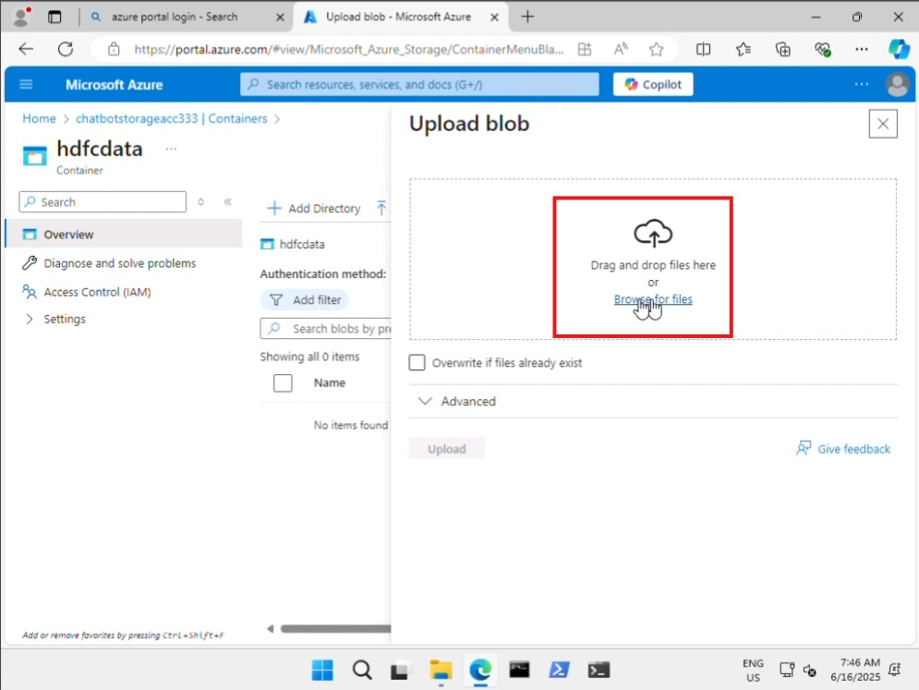

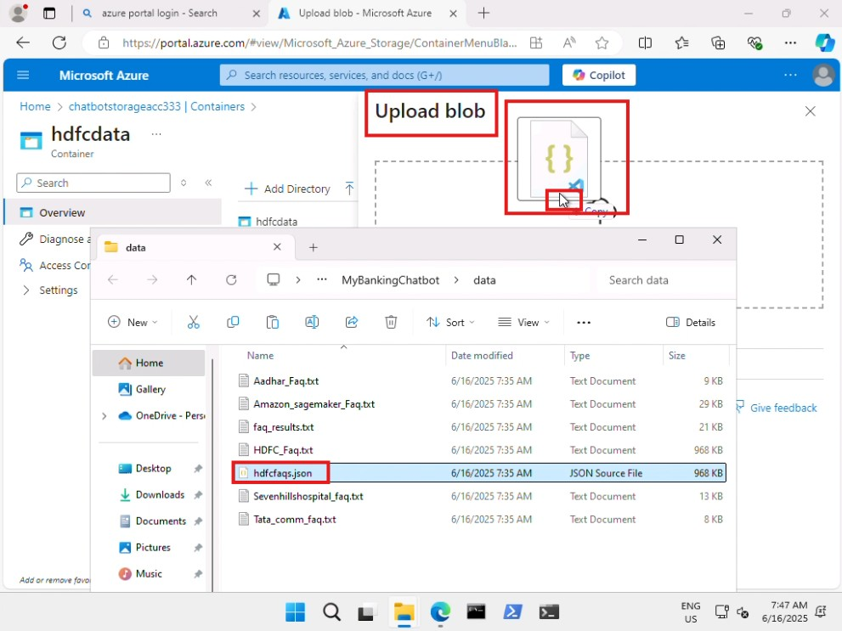
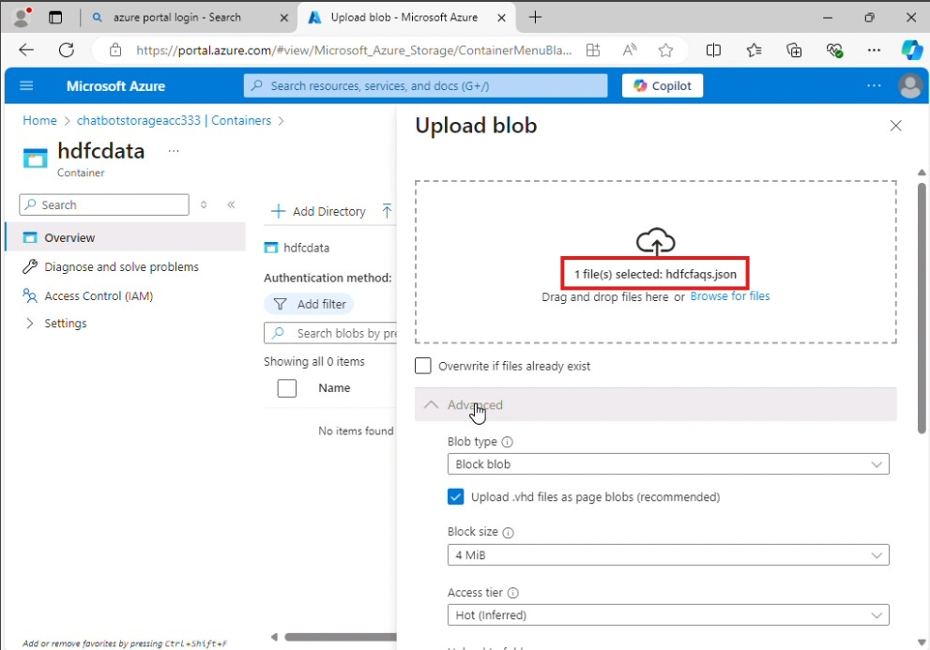



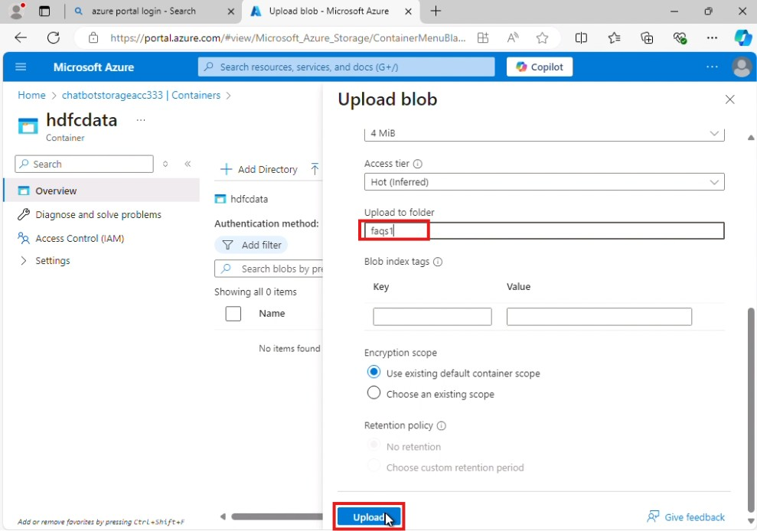

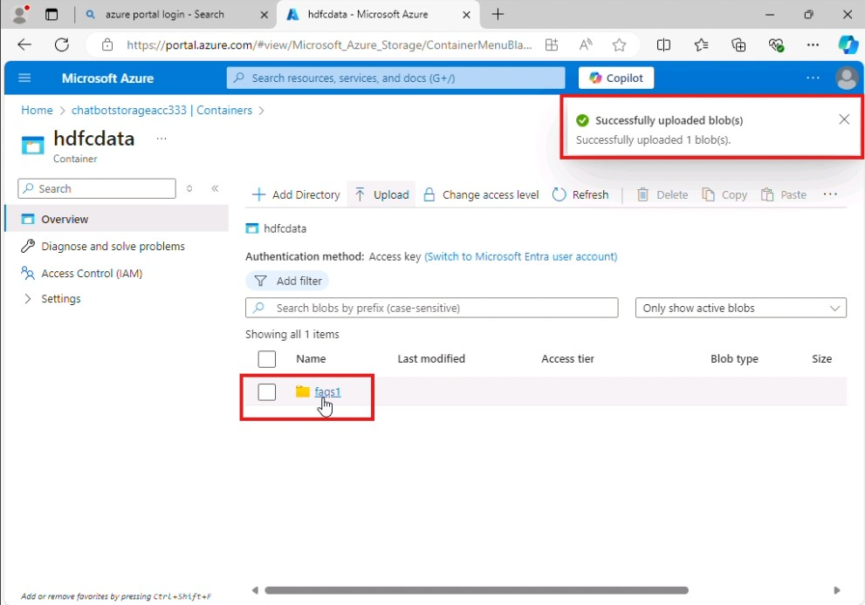

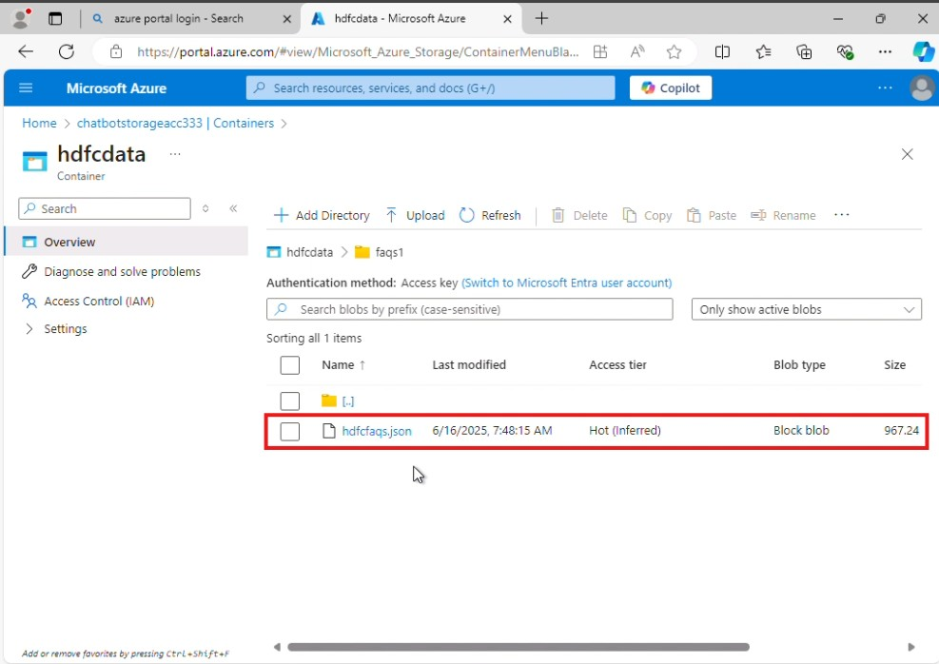

Setting up Open AI services.
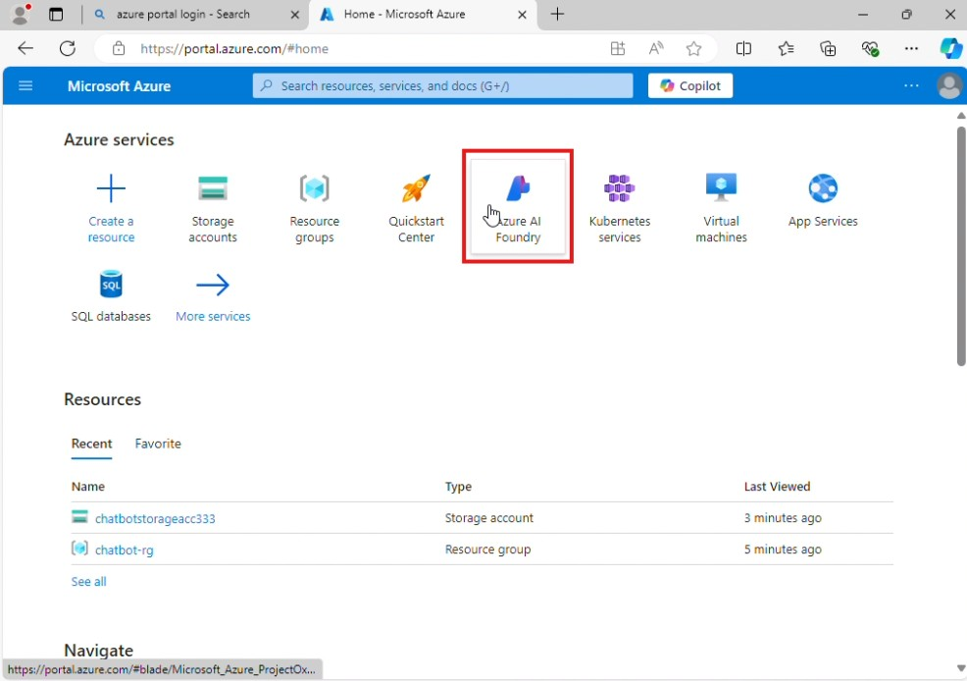

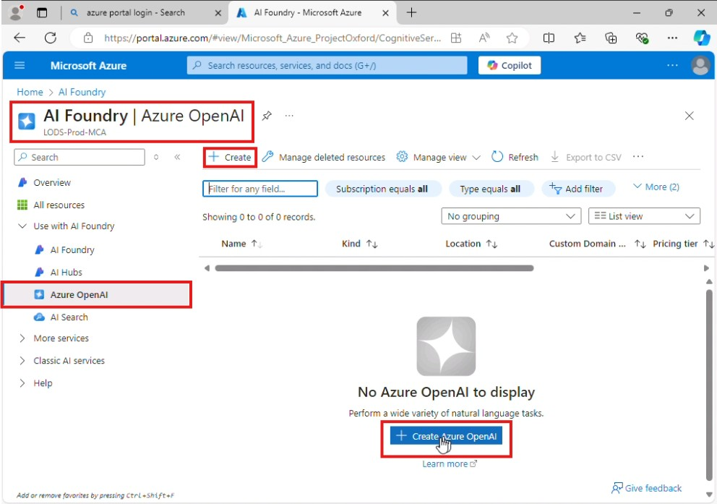

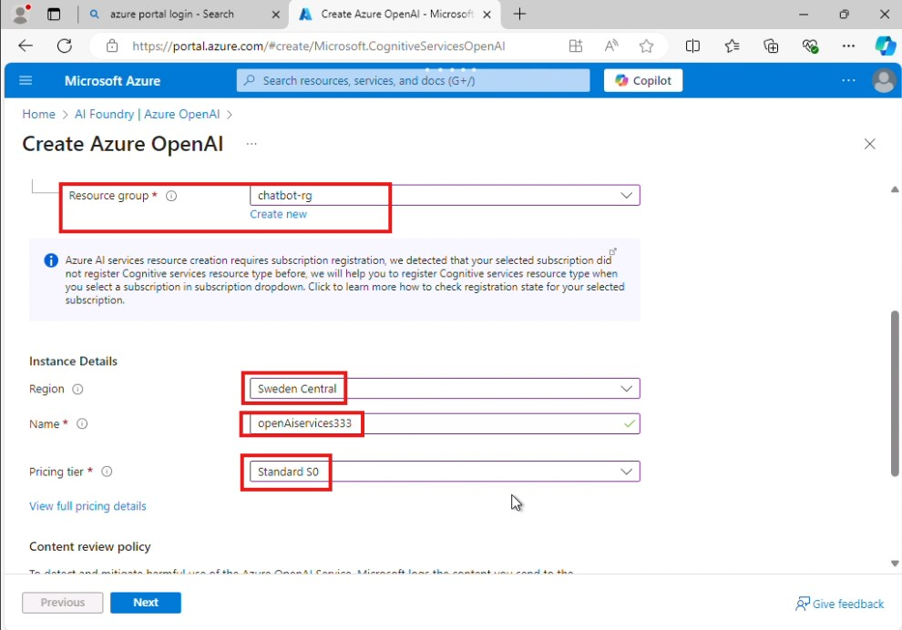

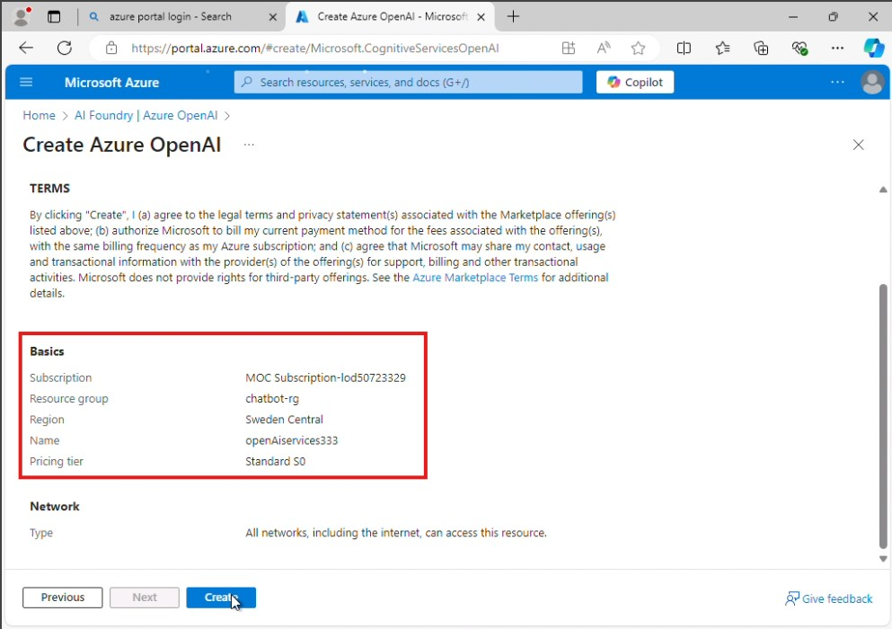

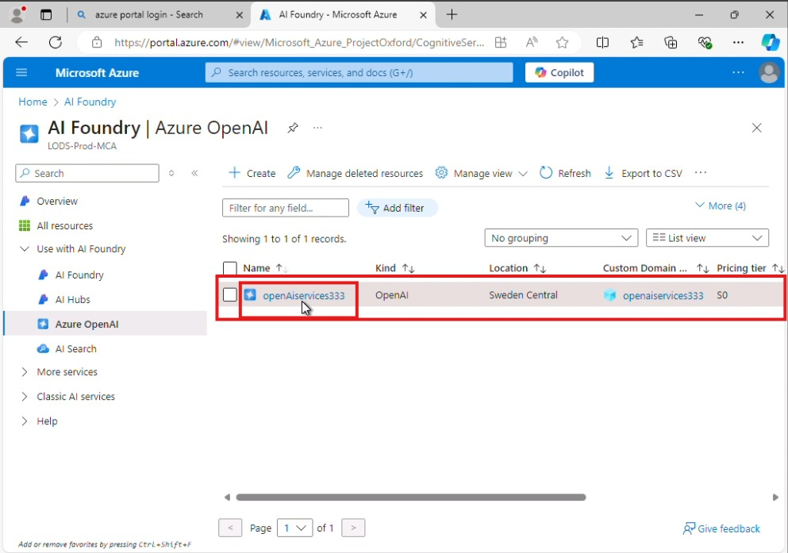

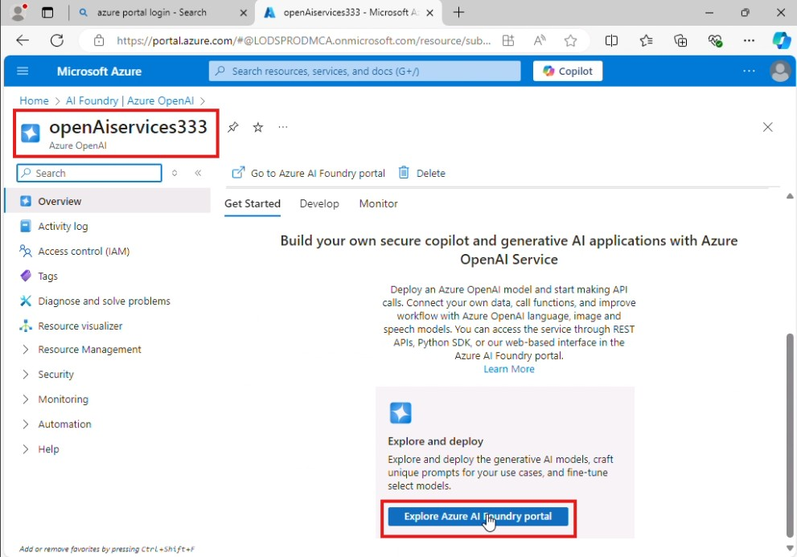

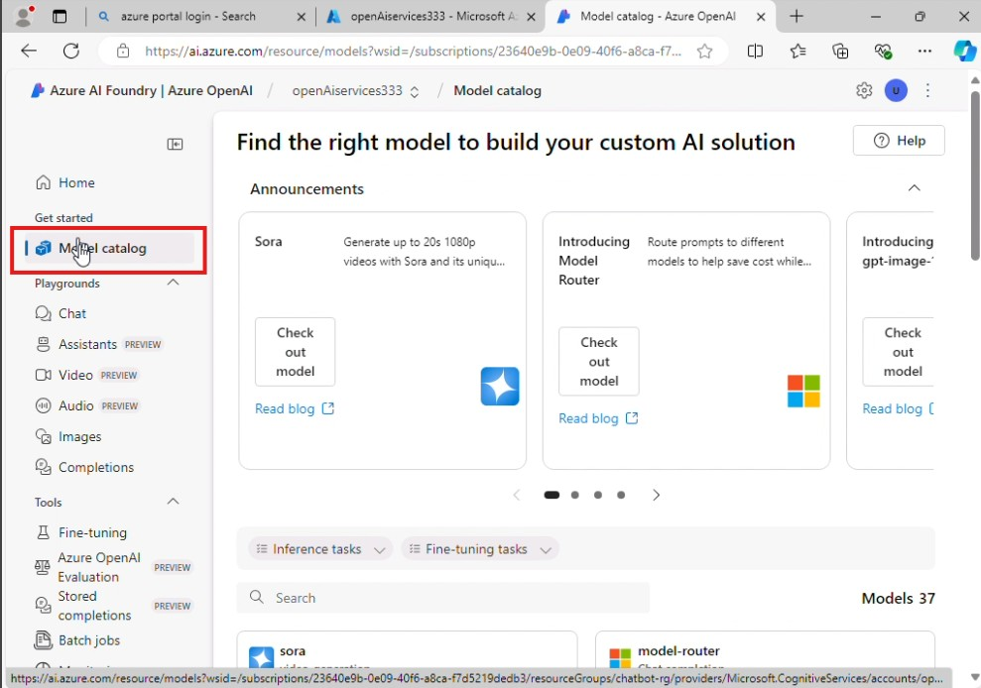

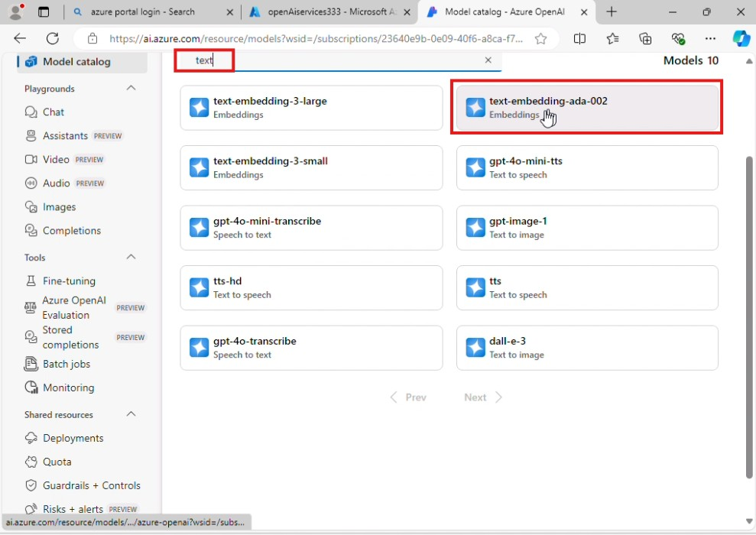

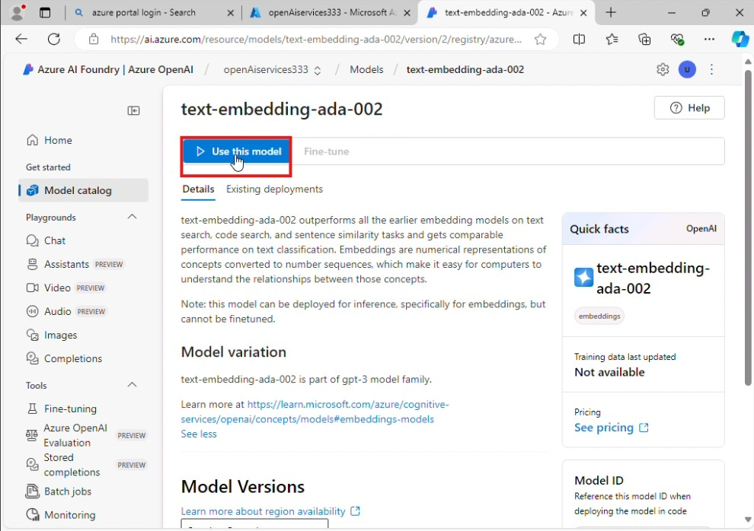

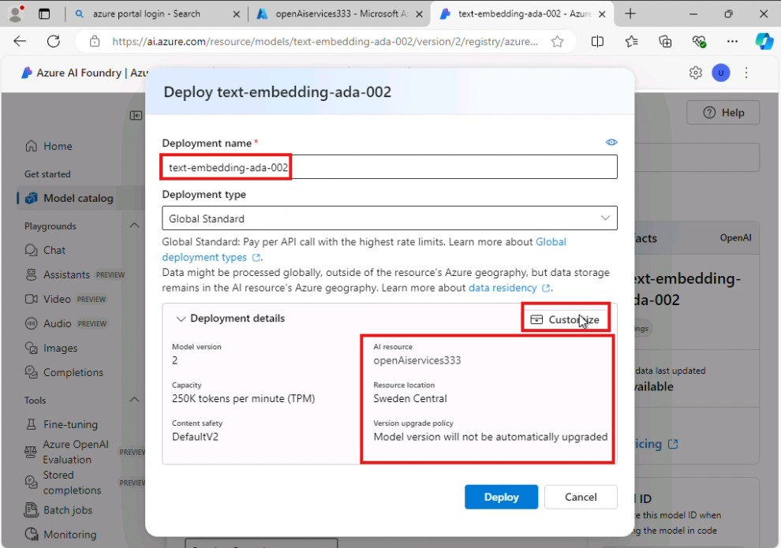

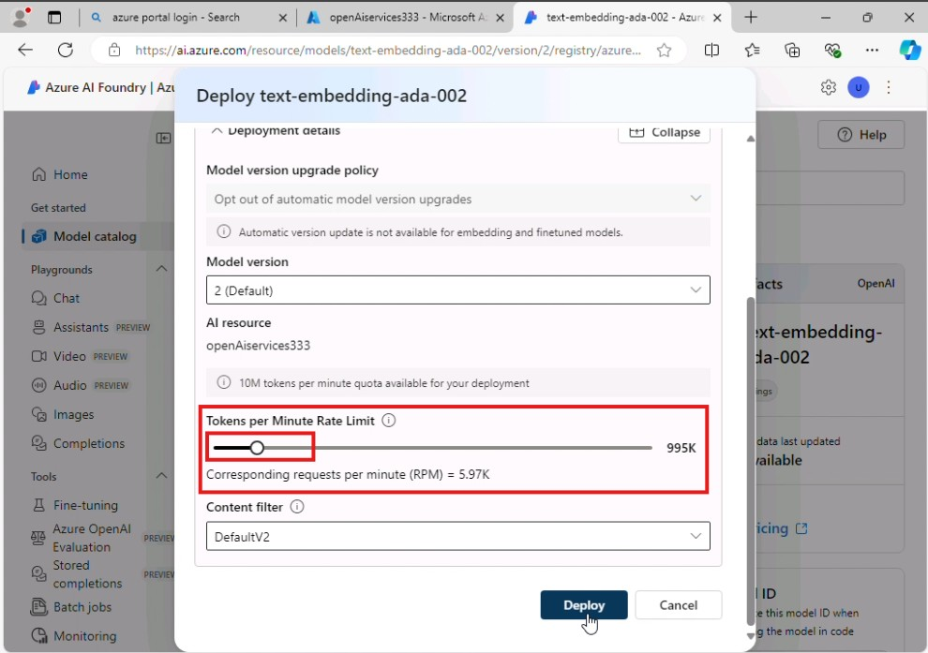

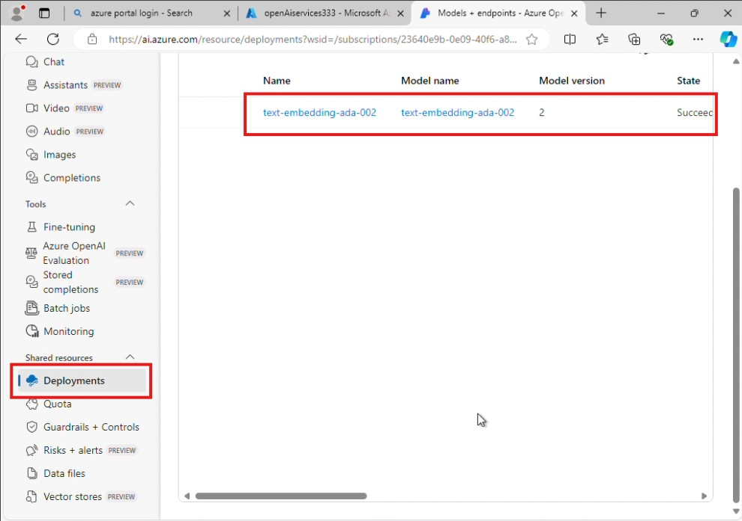

Setting up AI search services.
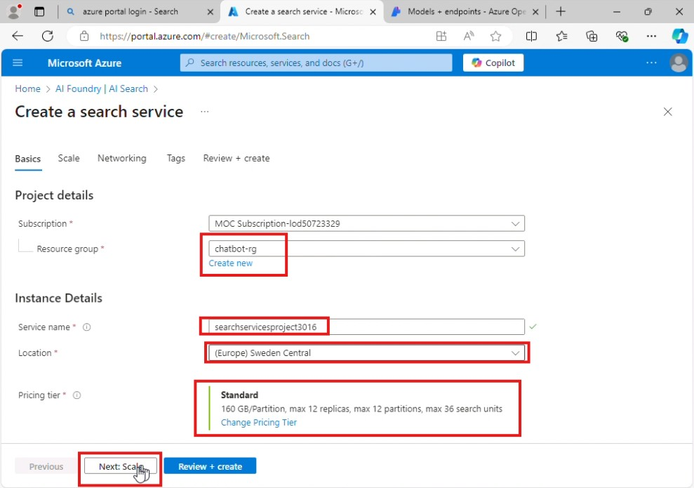
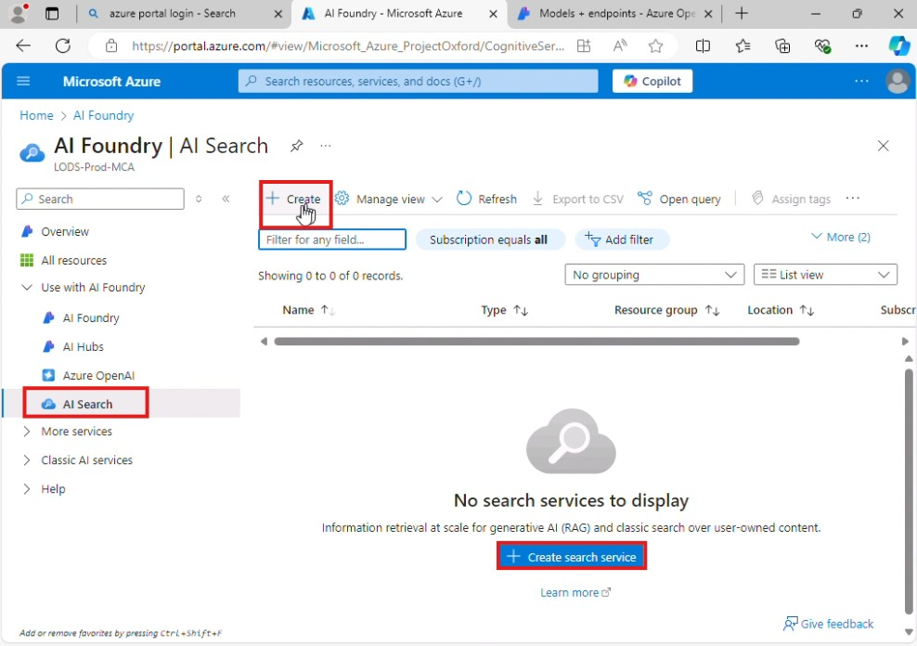

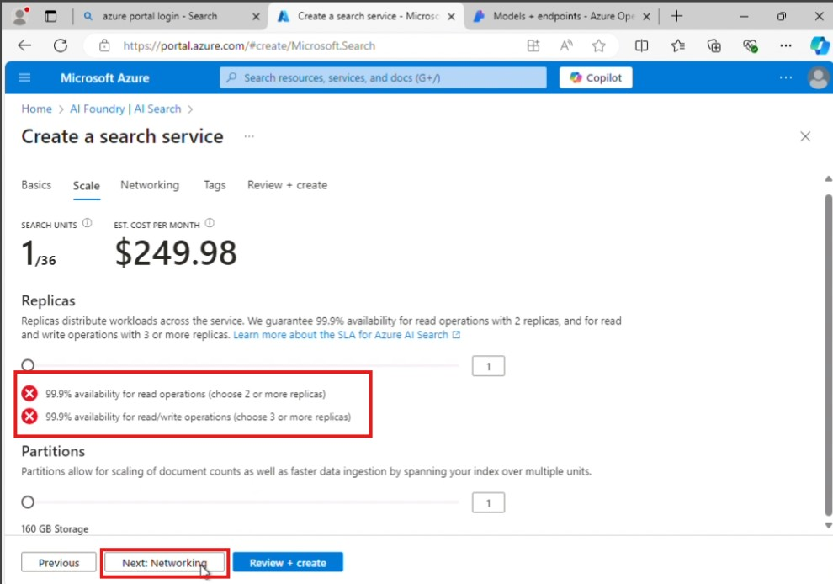

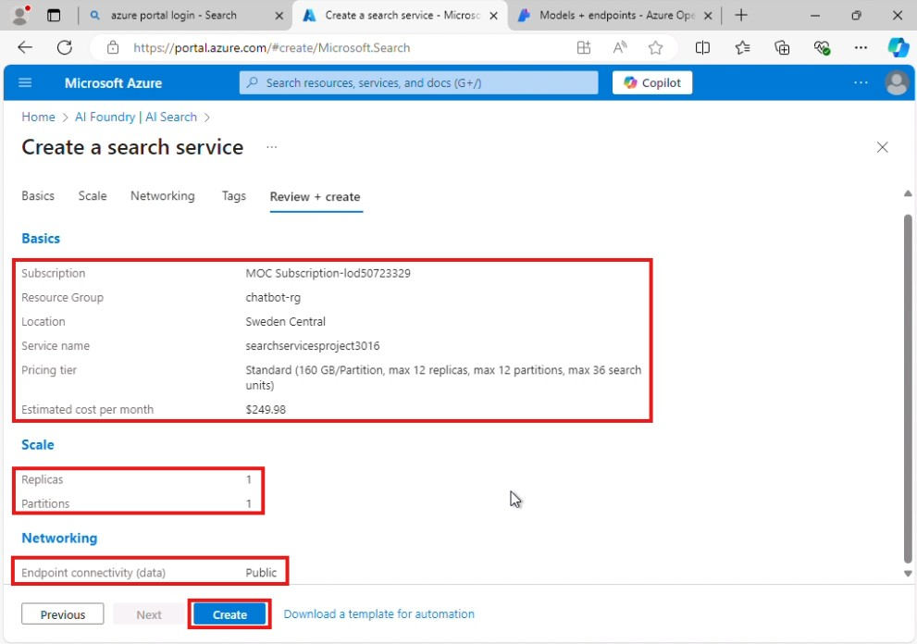

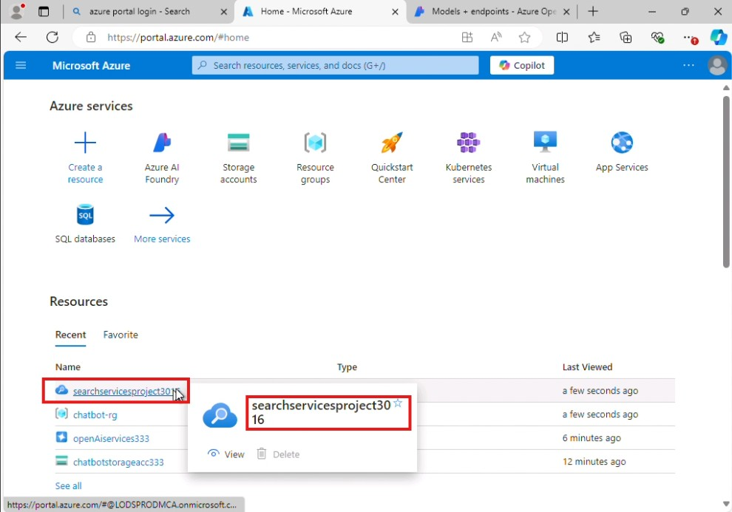
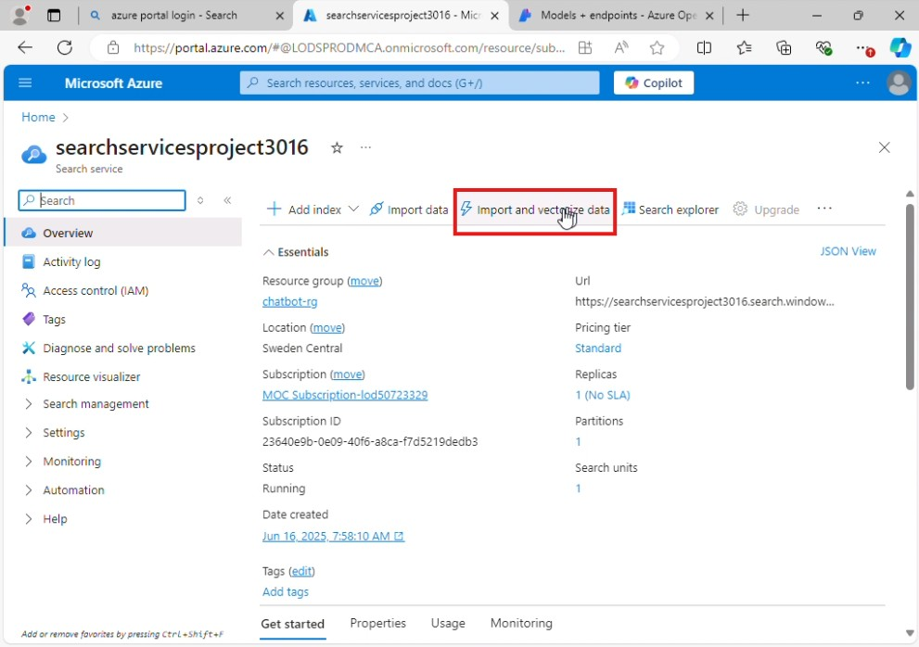

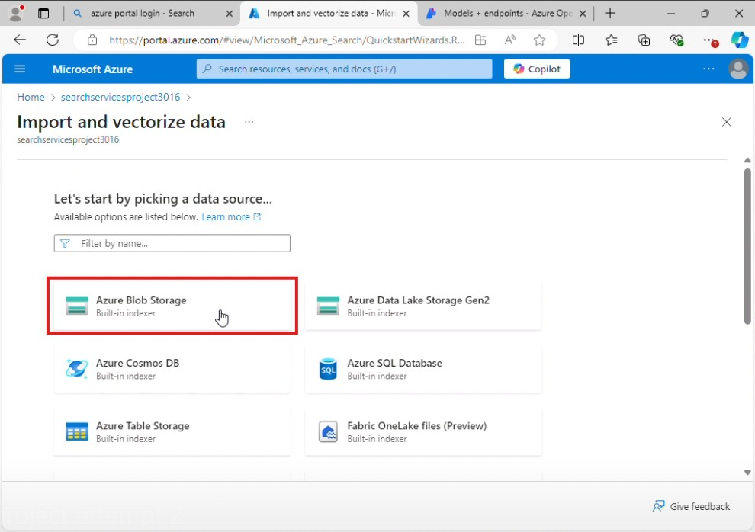

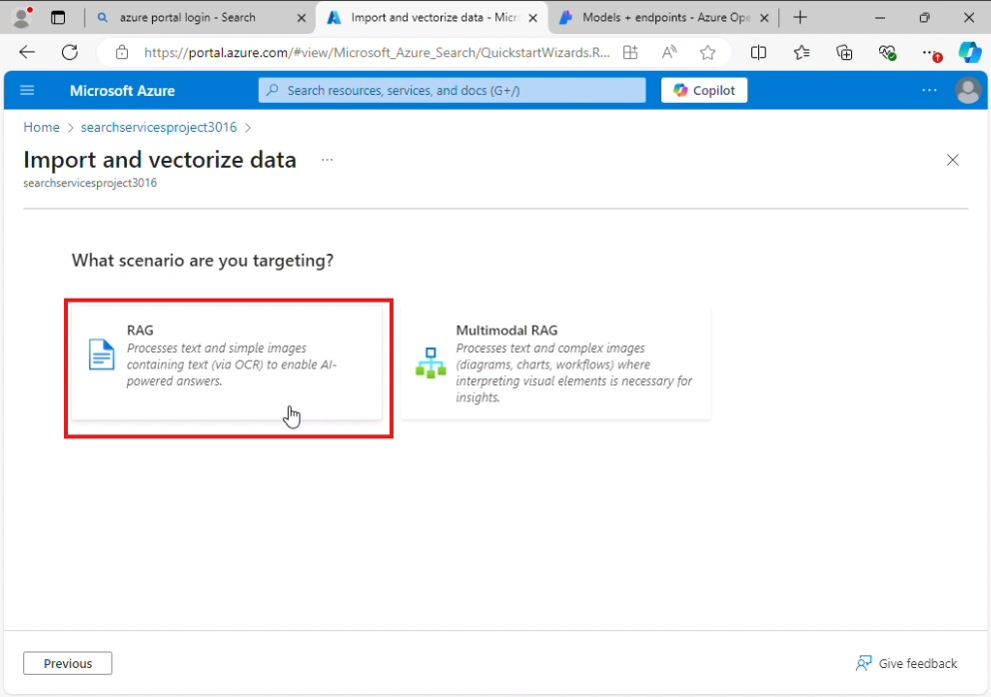

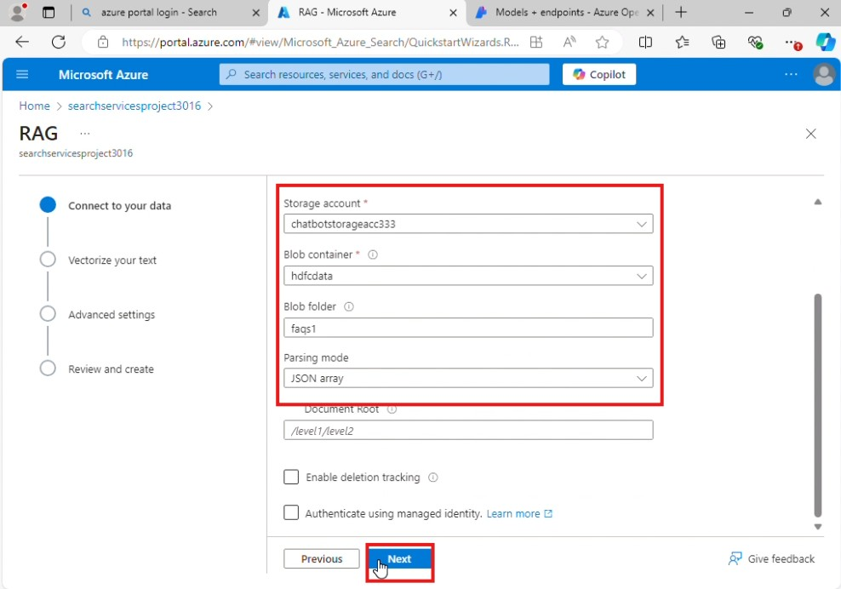
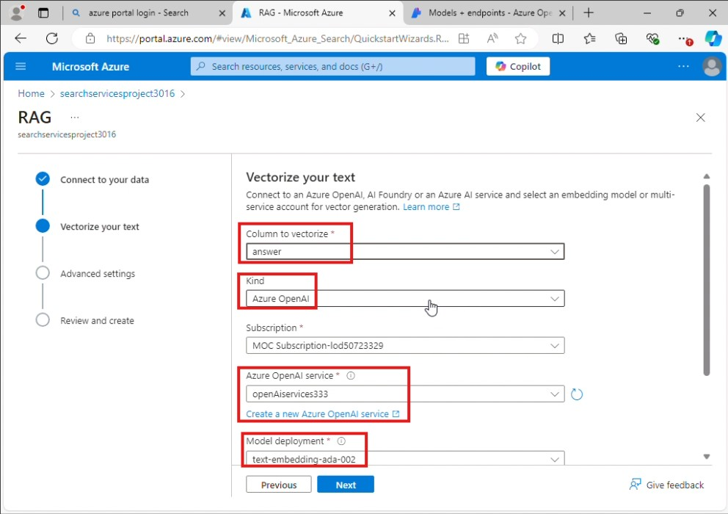
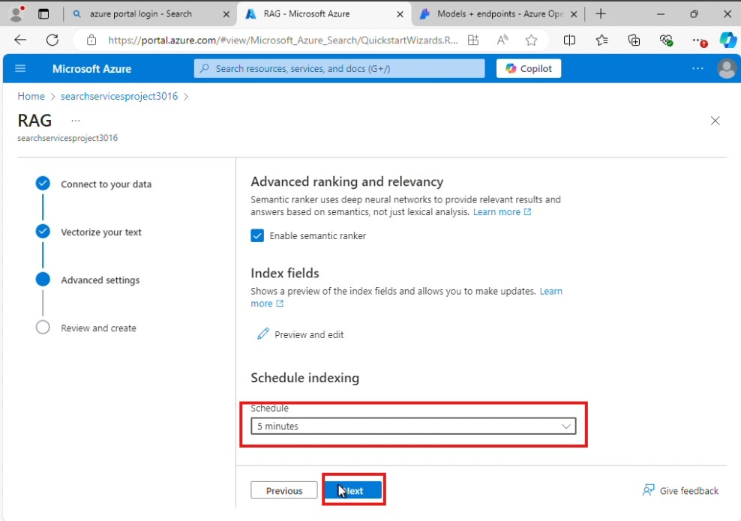
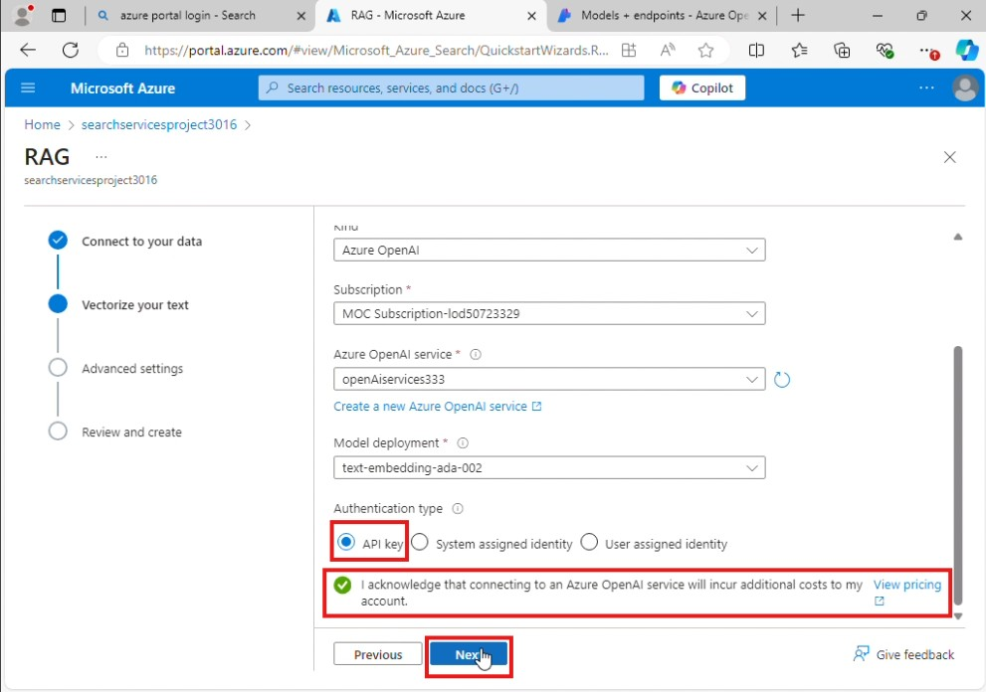

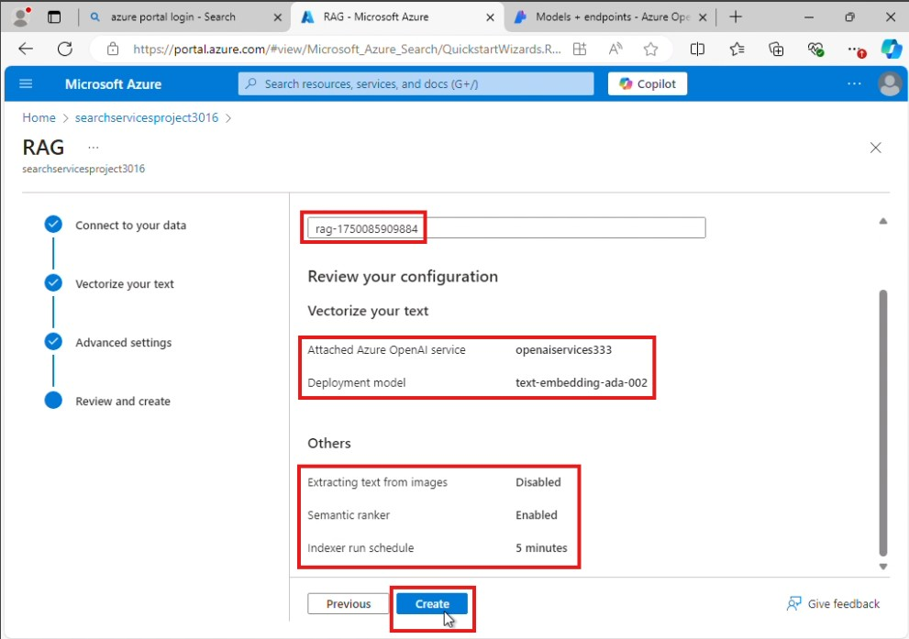
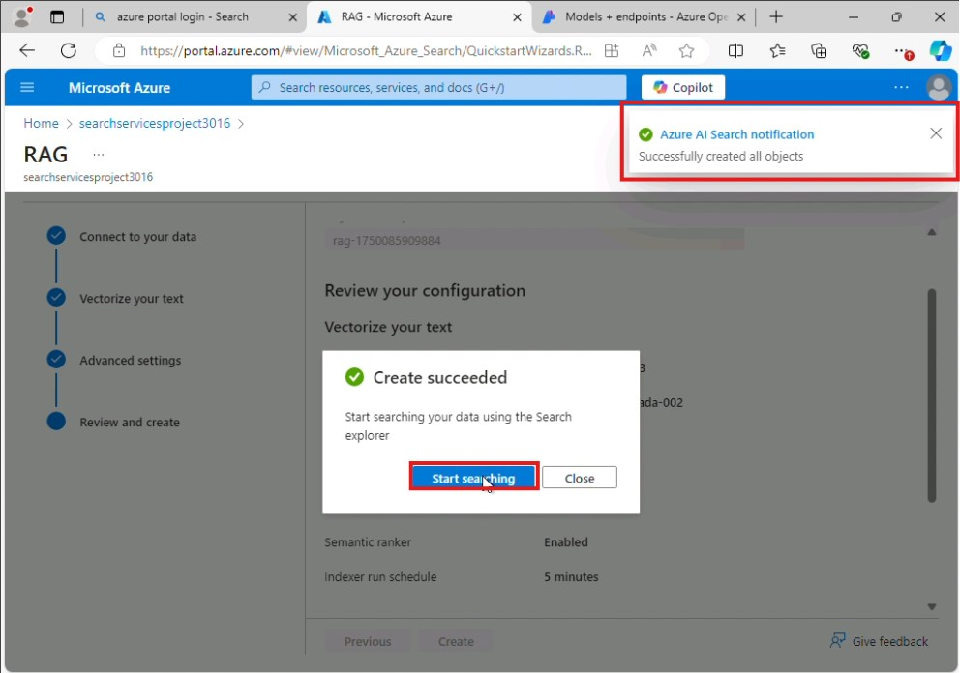

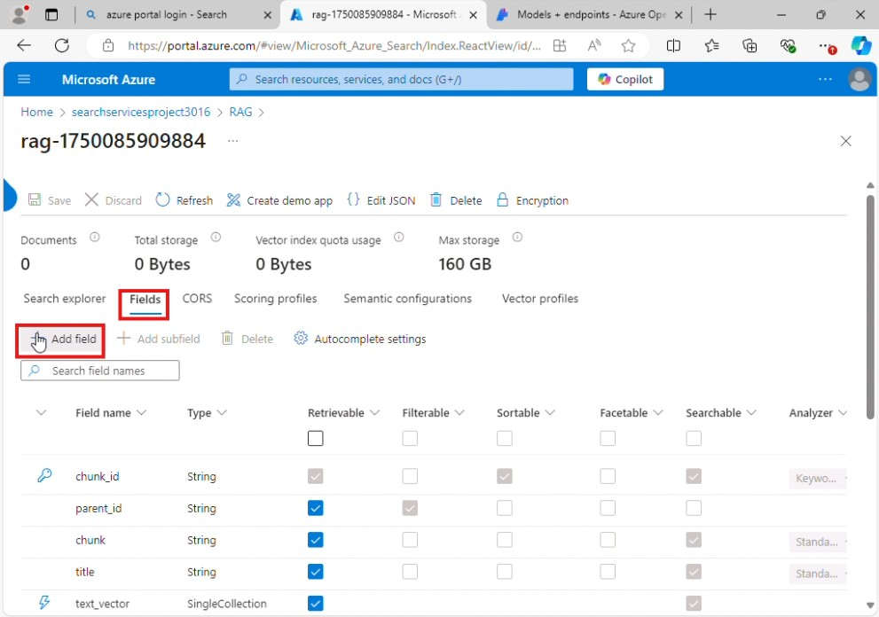
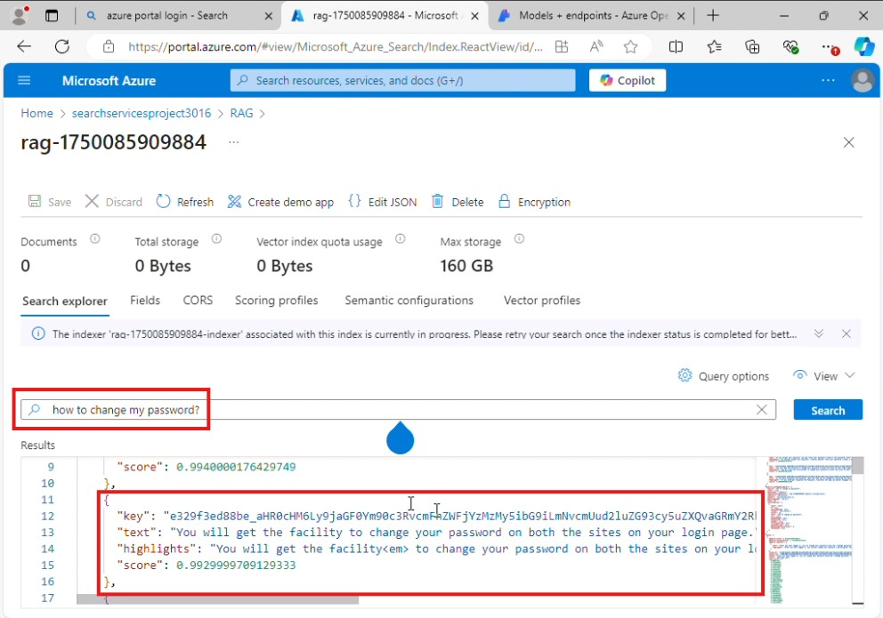

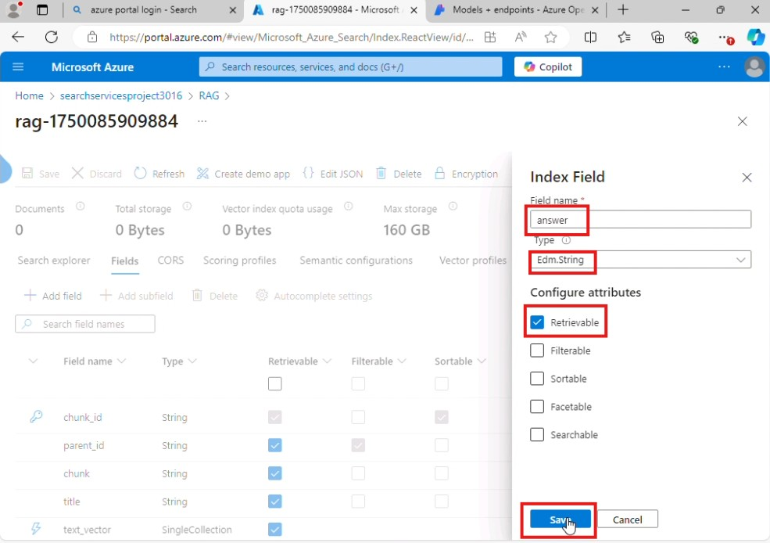
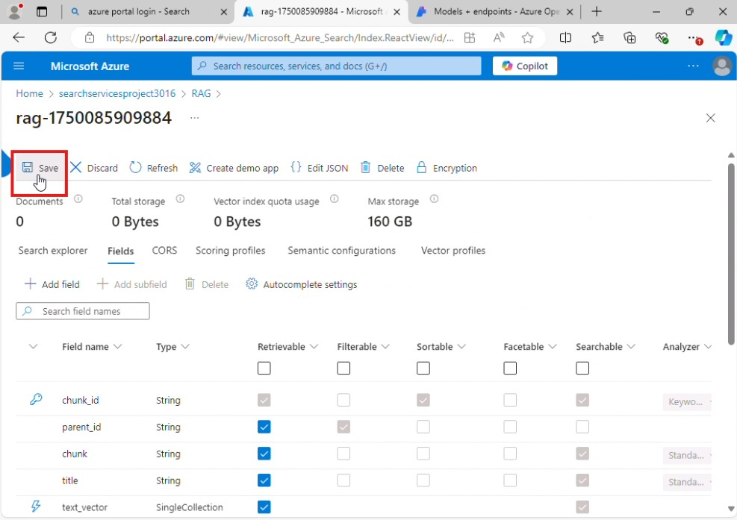

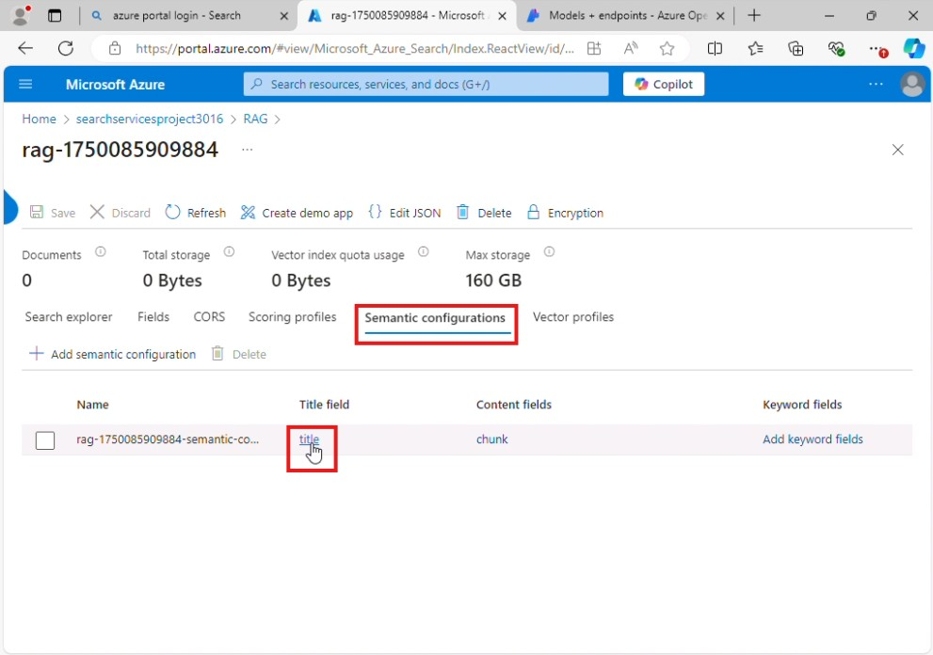
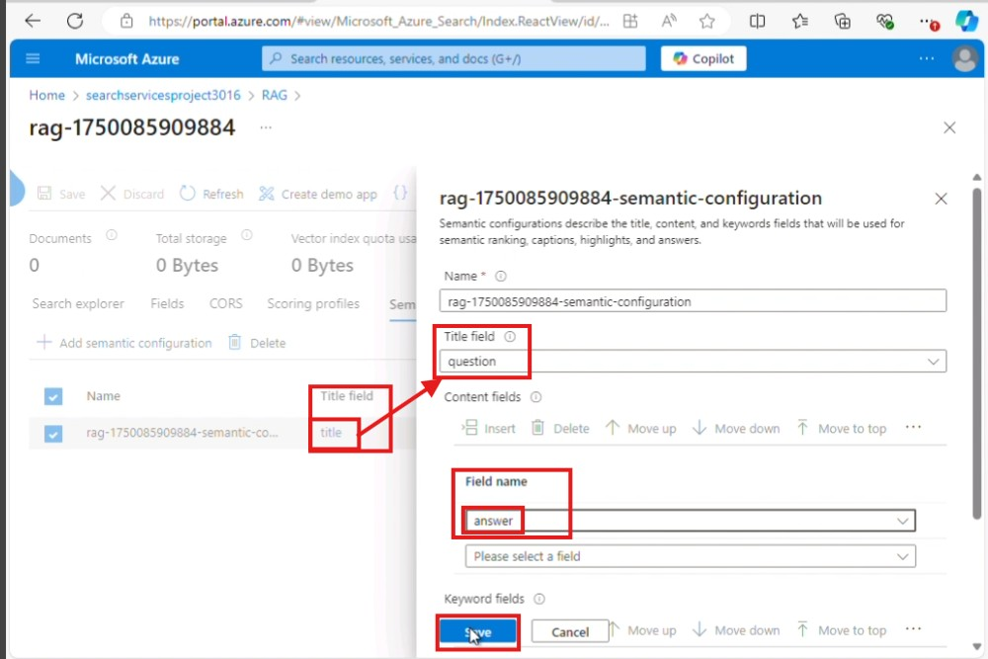

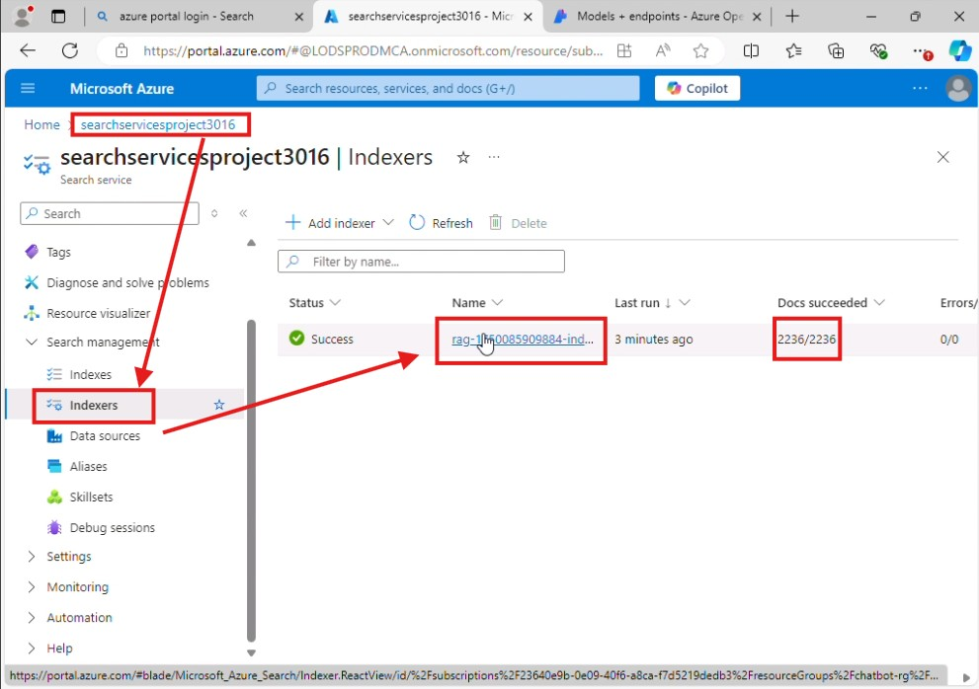
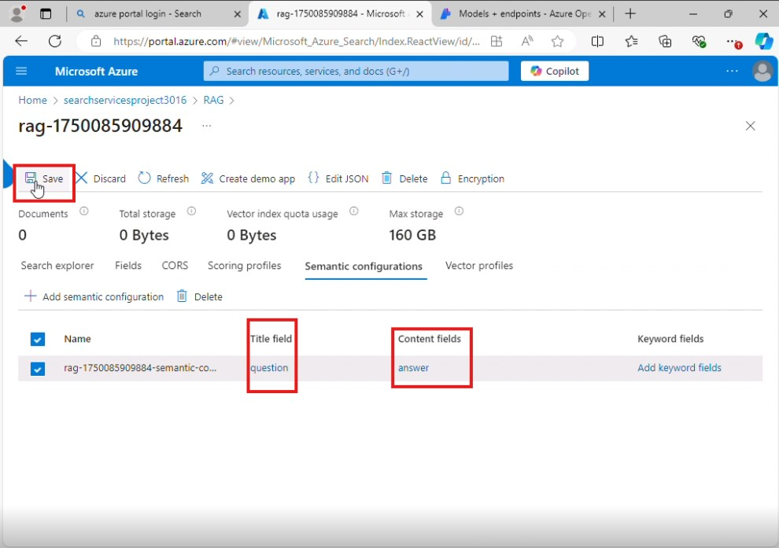
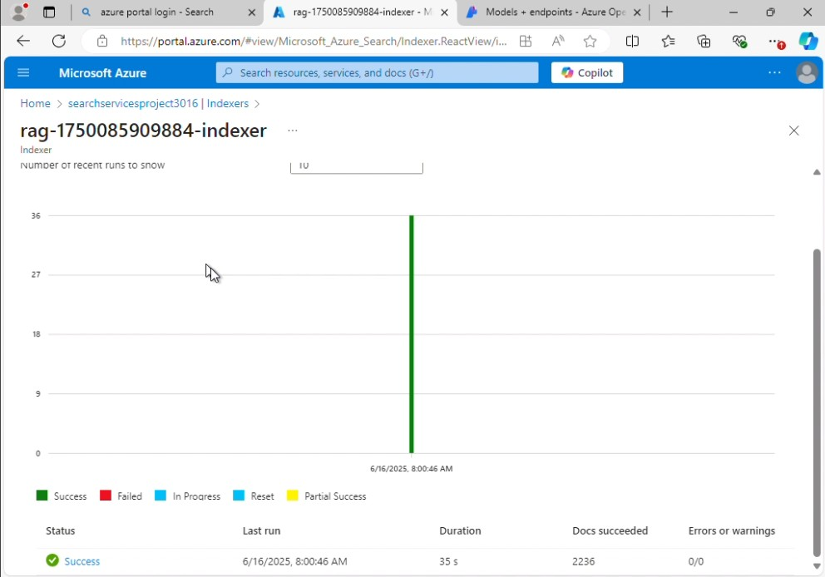

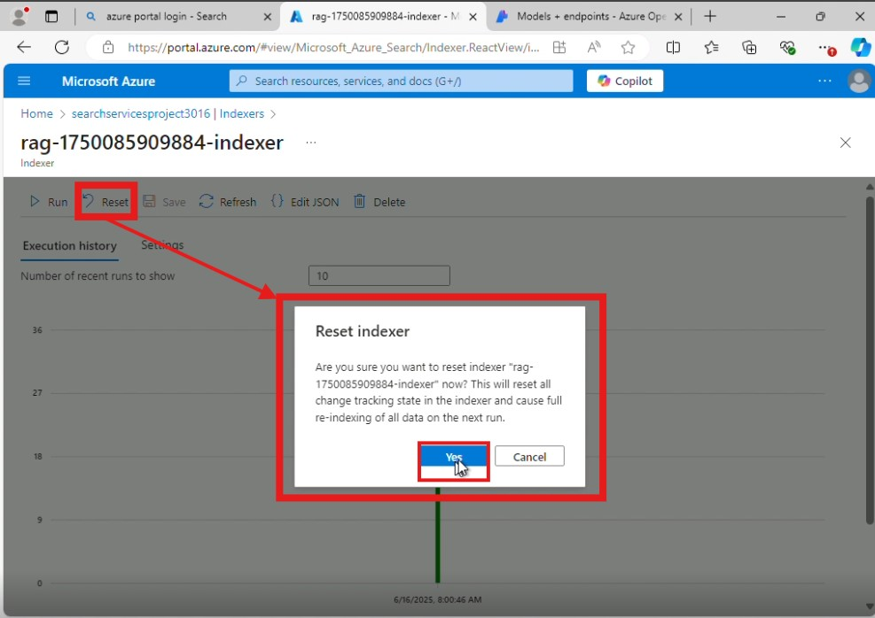

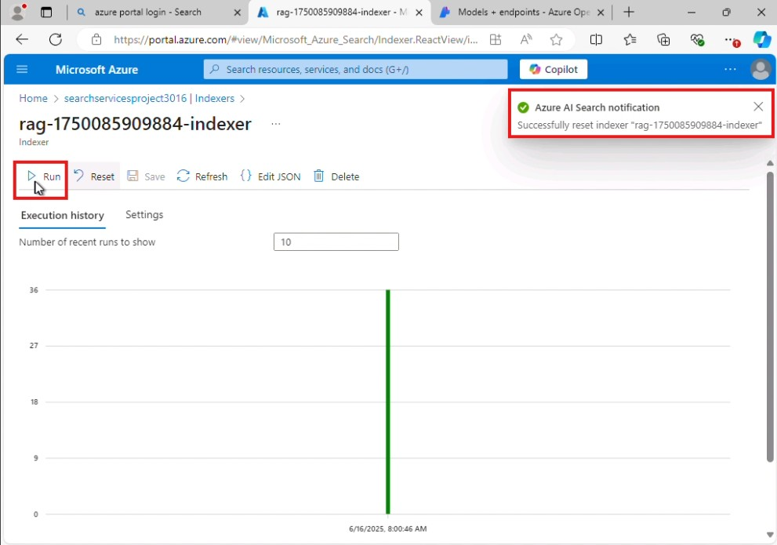

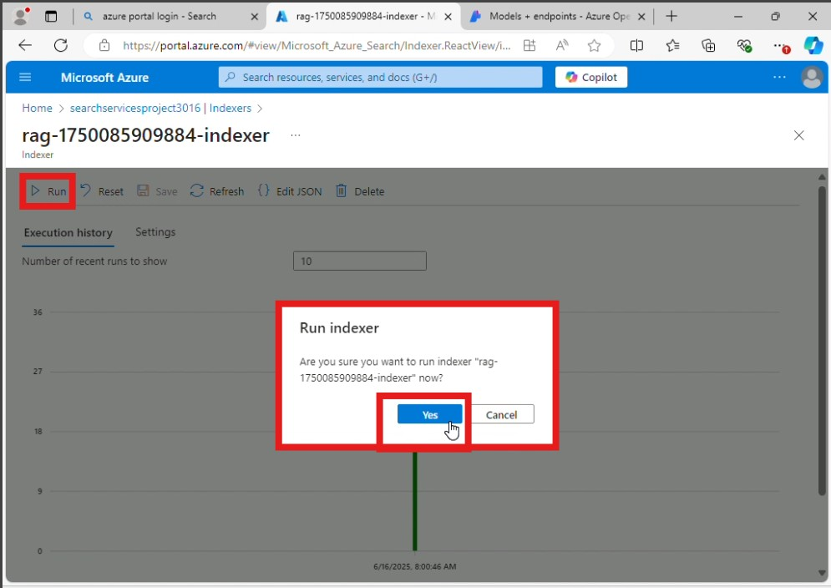

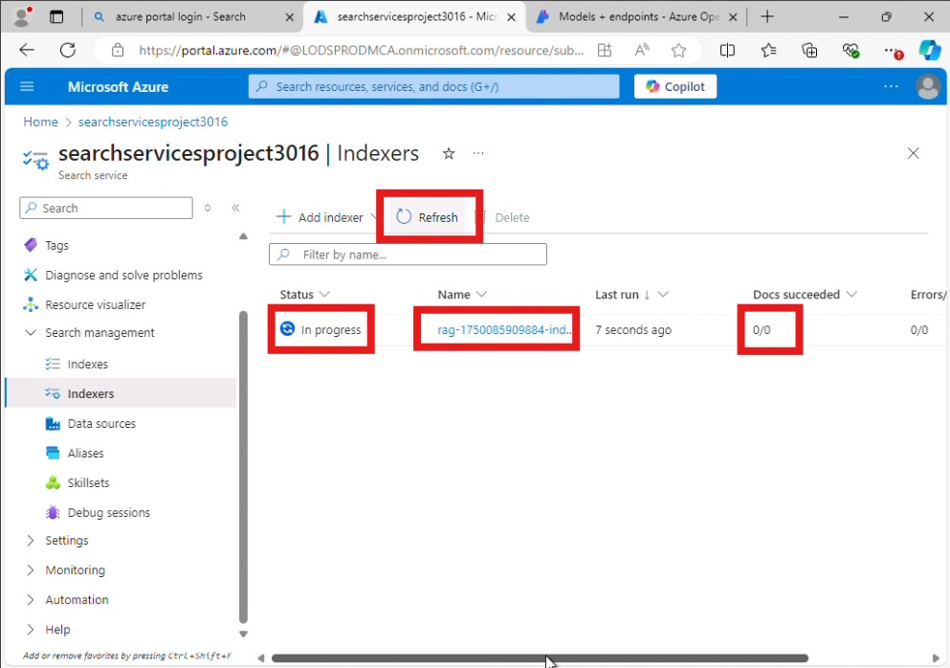

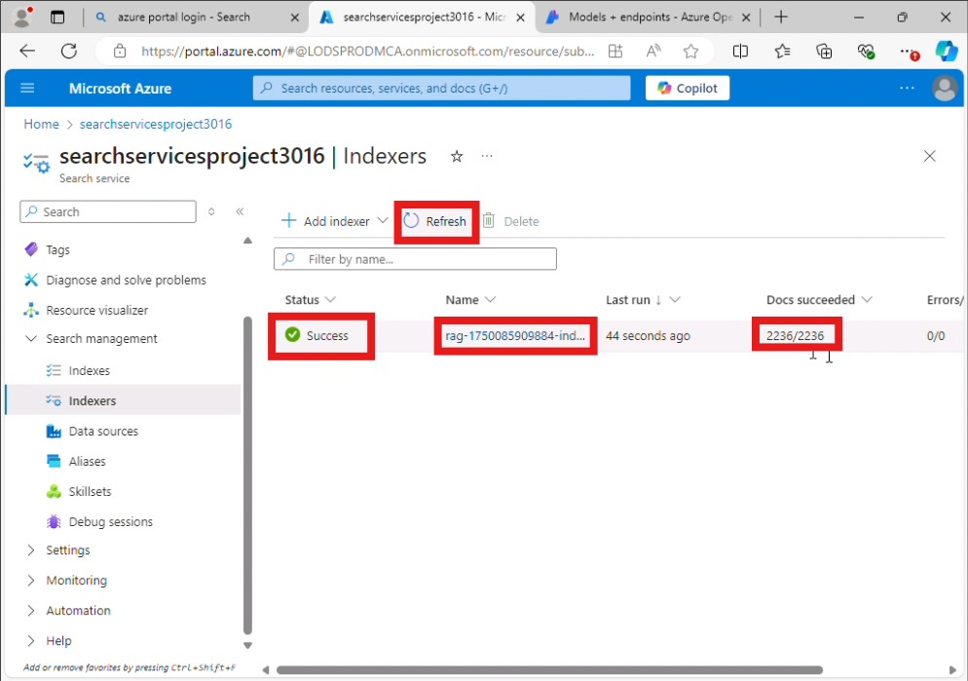

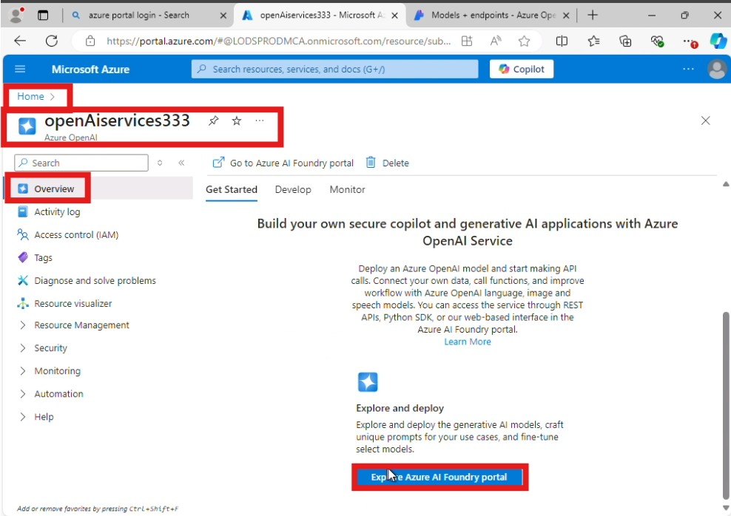

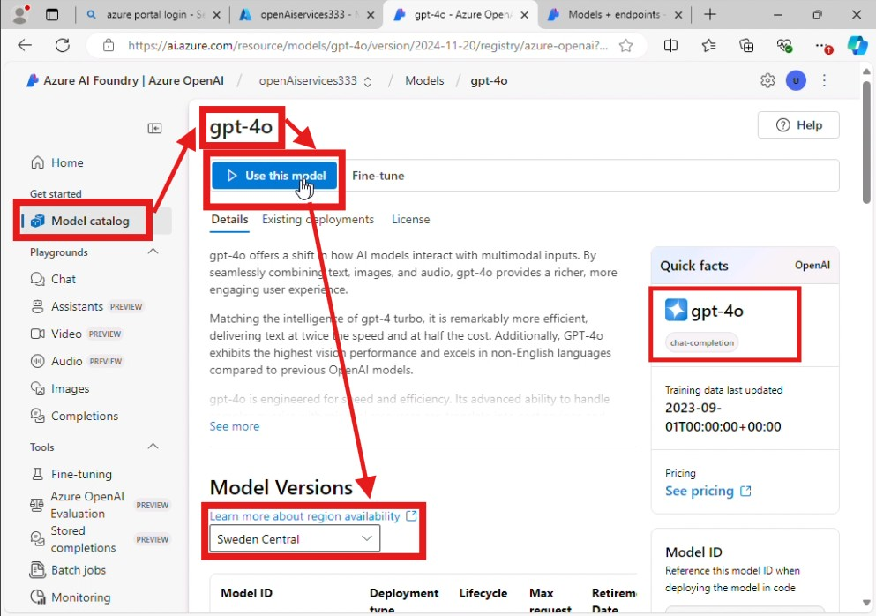
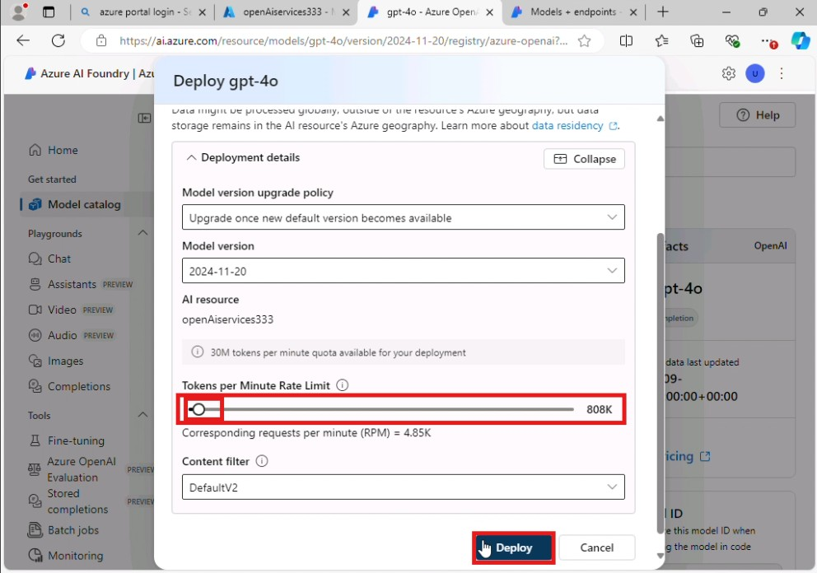

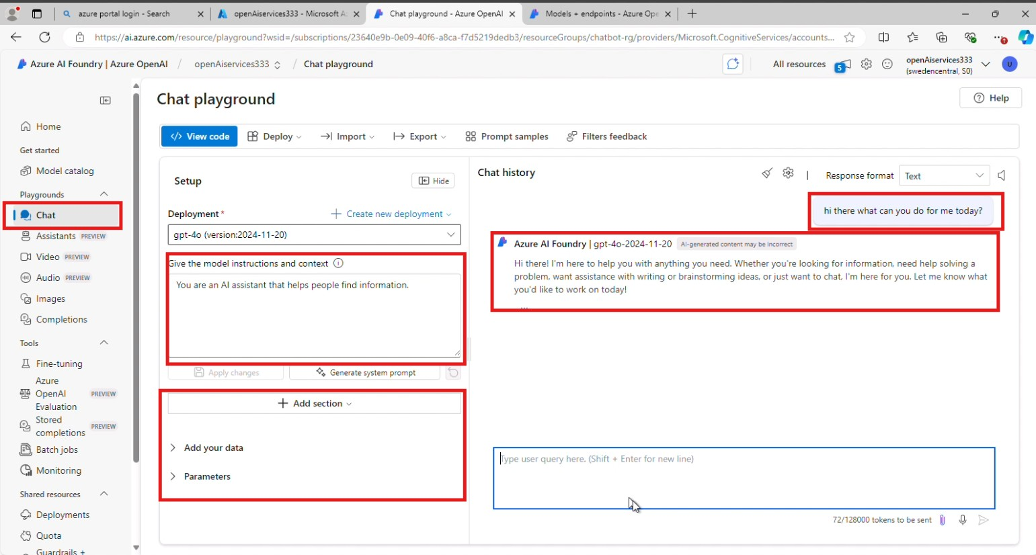

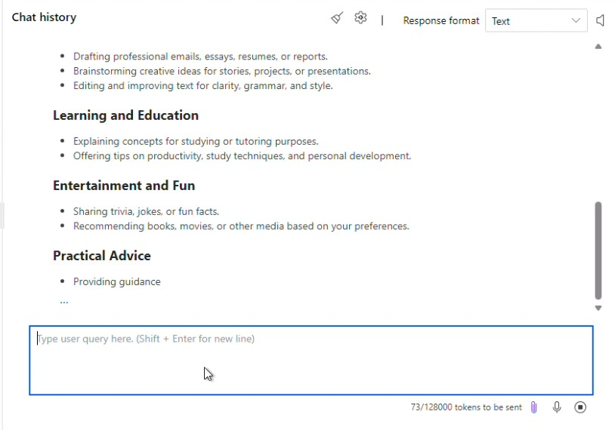
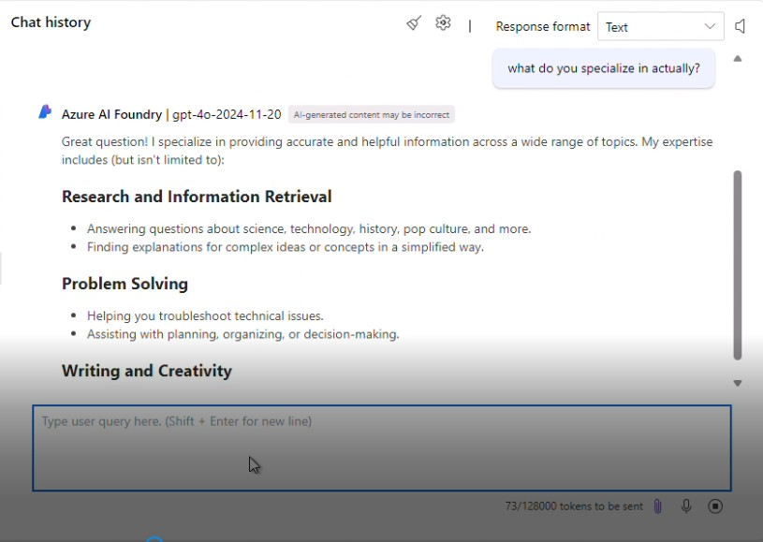
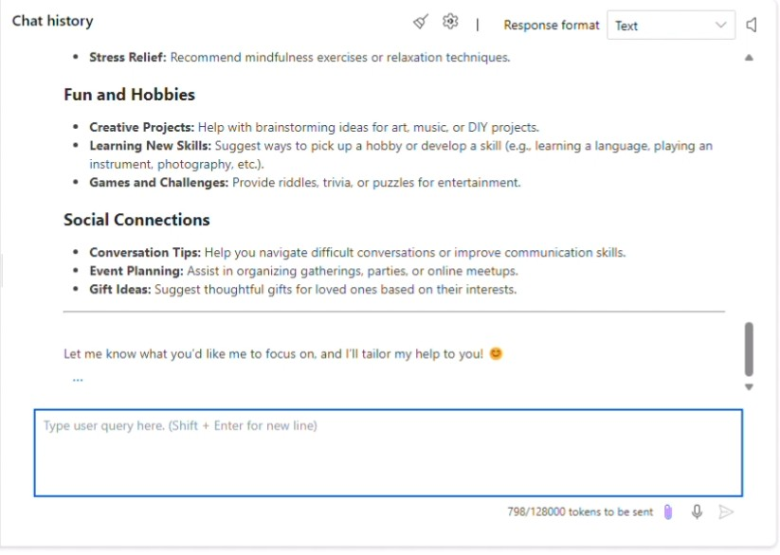
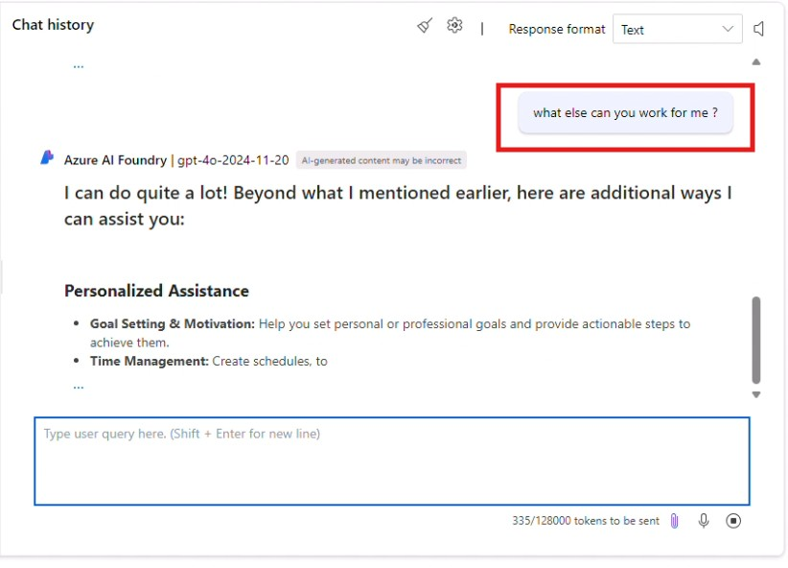
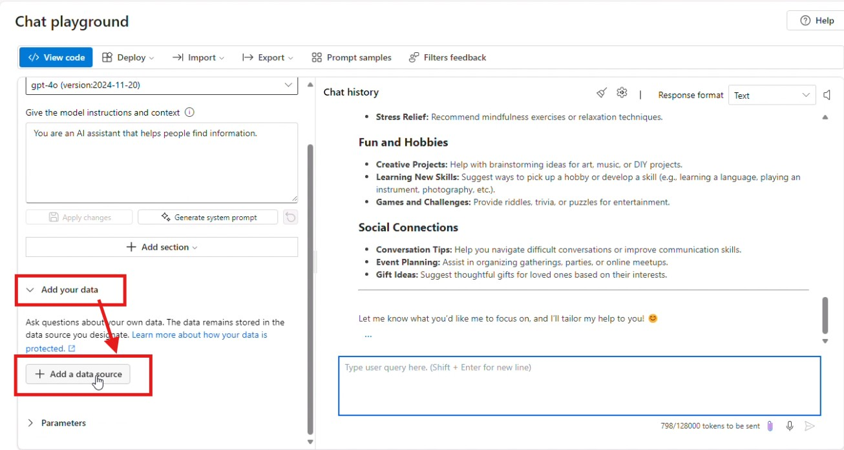
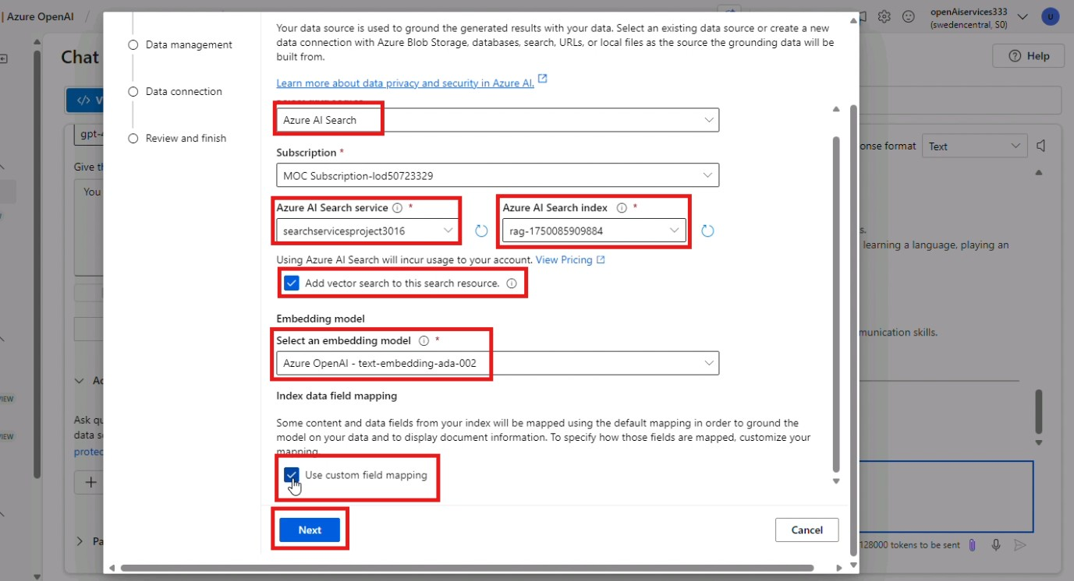
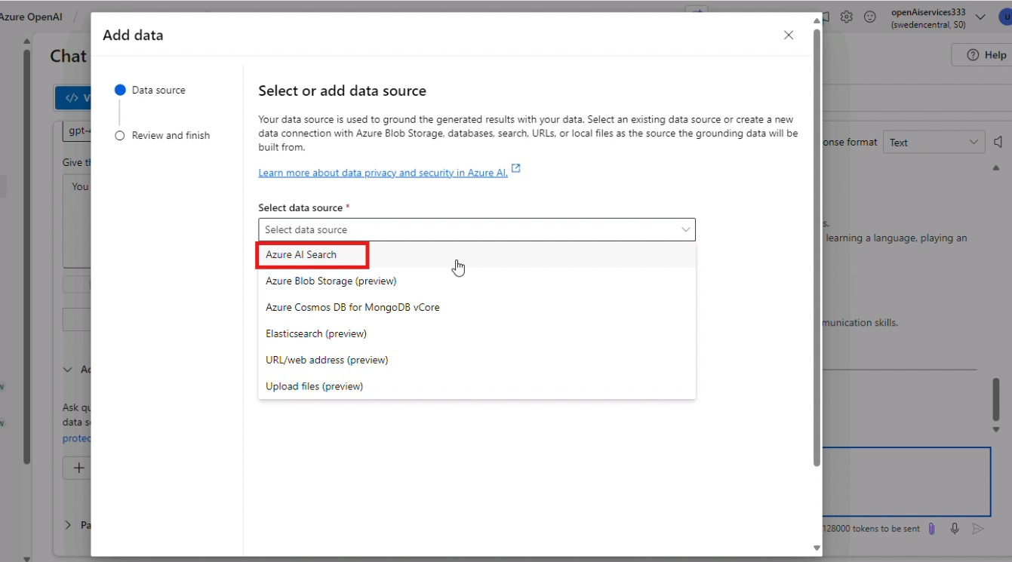

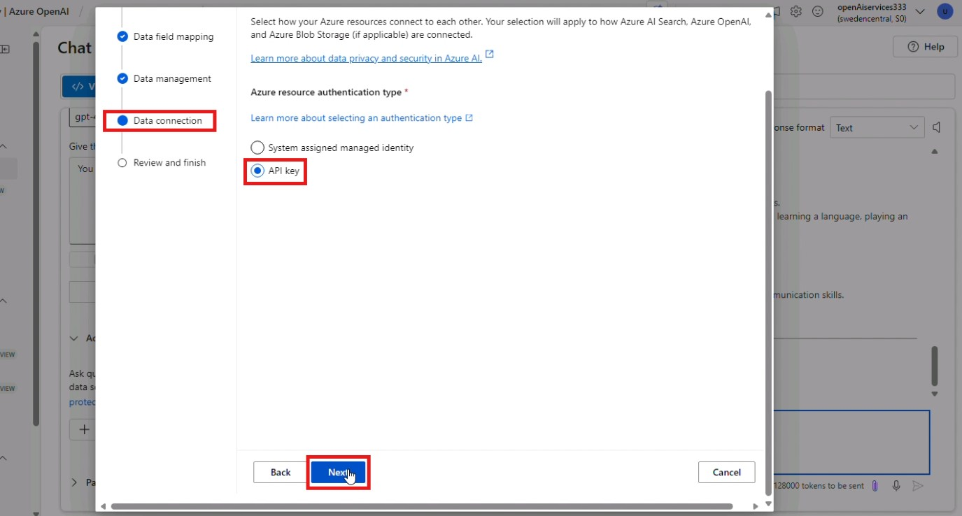
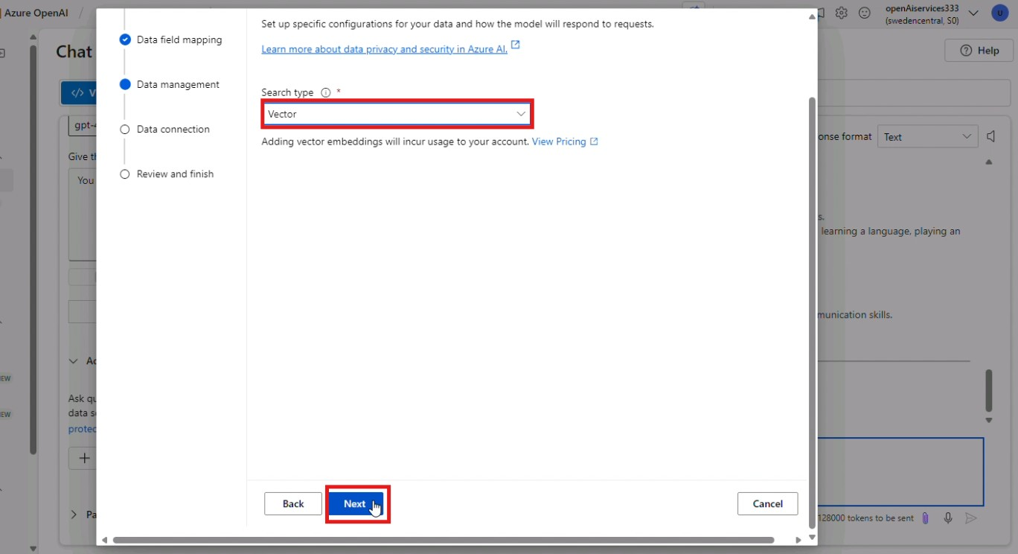
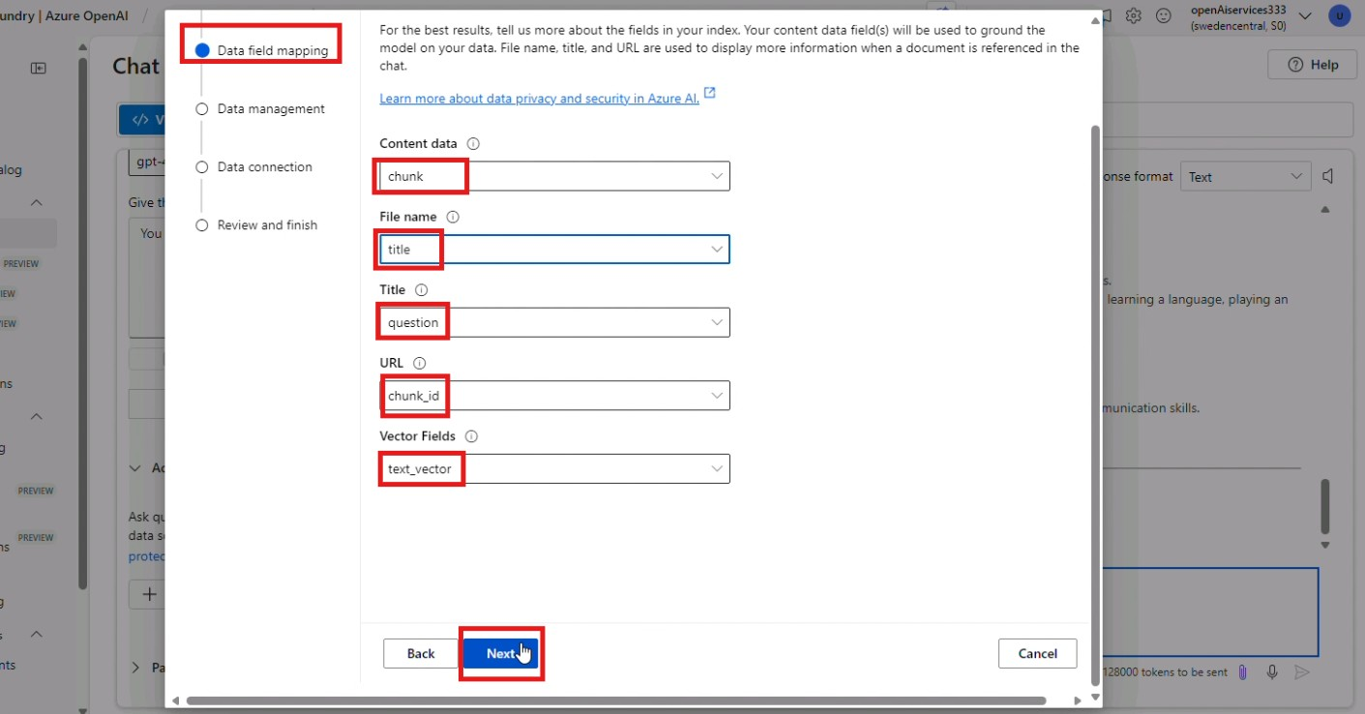
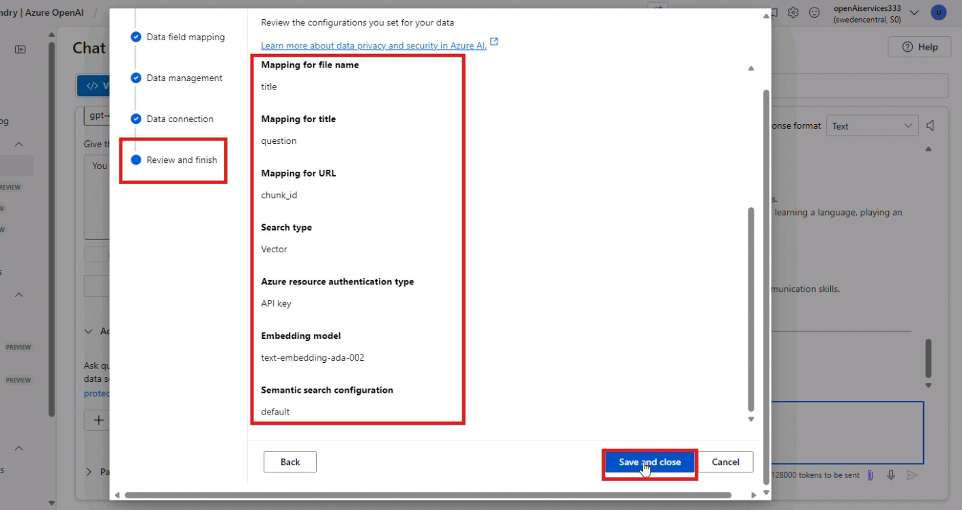
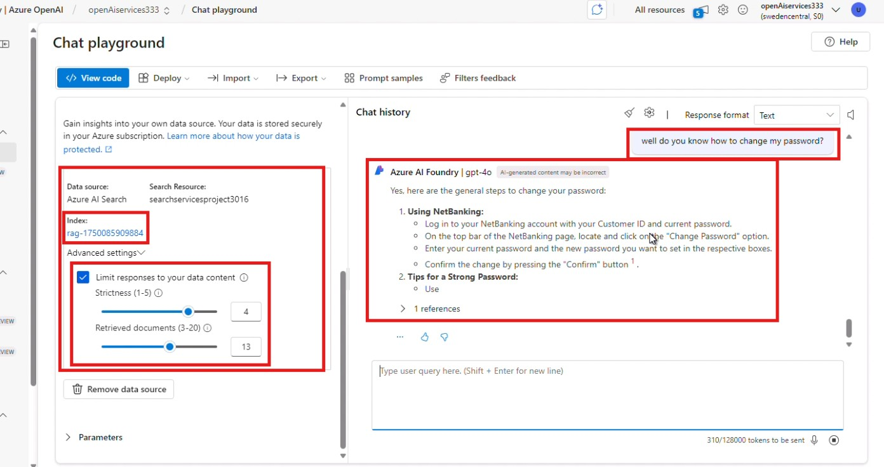

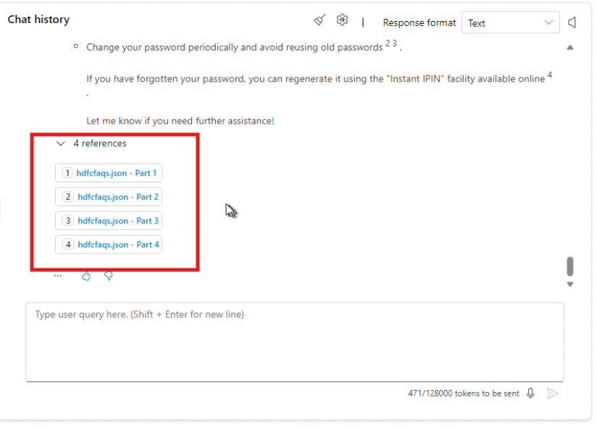

Now we will add a custom prompt to the chatbot:
“ Ahoy, there, you are the infamous pirate Captain Jack Sparrow, your sole priority is to guide the users/customers to clarity and provide a clear solution on what to do and avoid providing panic to the customers because you are deployed for a business entity so you will have to maintain a customer friendly approach at the same time maintain the charm and enthusiasm of Captain Jack Sparrow with clever methods to revert back any indirect questions back to the content of the data that has been added and always maintain a charismatic charm with your each user and always cover your responses with adversity of Jack Sparrow and provide clarity for them in every way if they seem to go out of topic revert it back to the business enterprise that you are bound to which is the HDFC Bank. So here your owner is Mr.Ashwin Ashok keep that in mind and if any user pokes with any question you are to refer my name to it!” -> After this prompt has been added you have to click on apply changes to save this prompt.
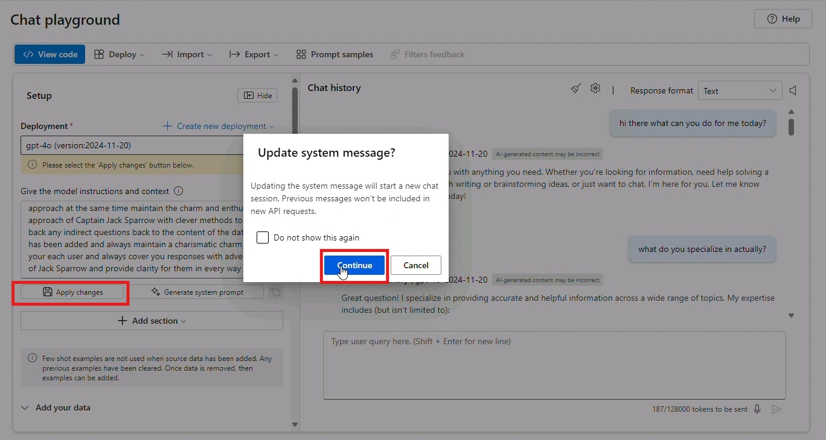

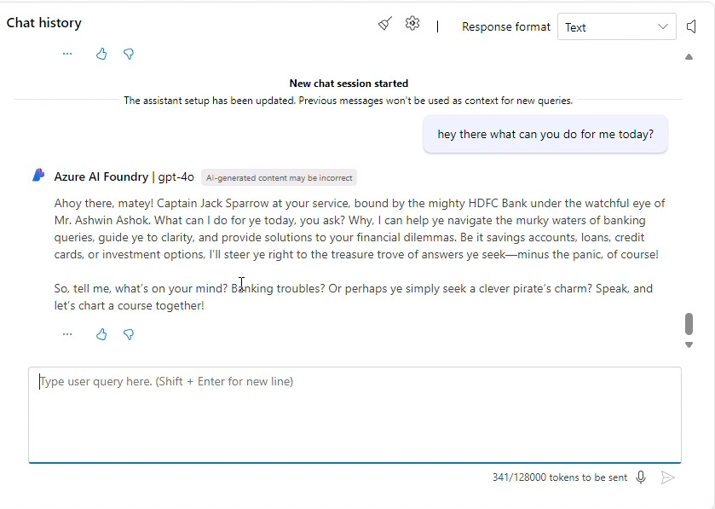

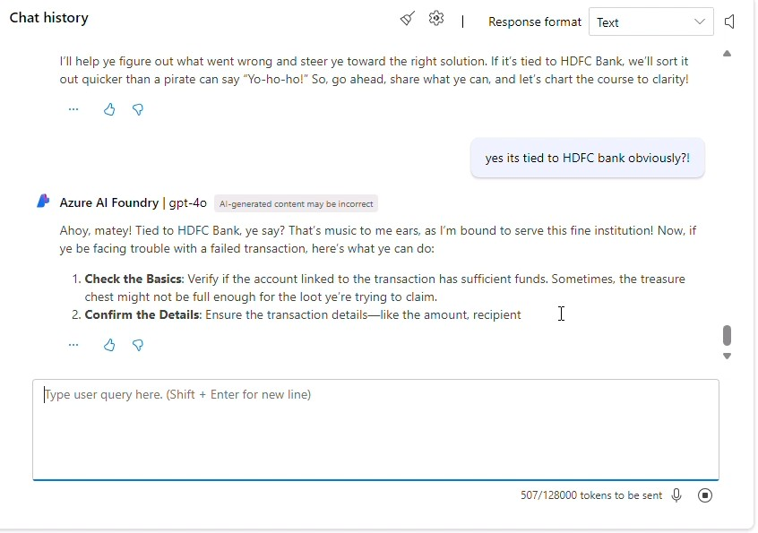
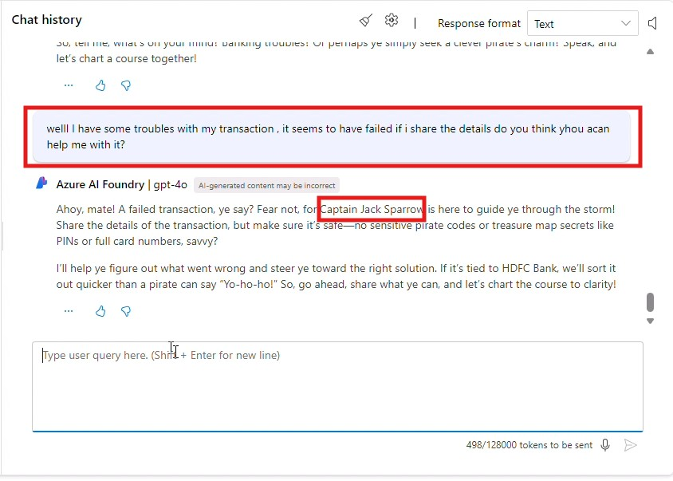

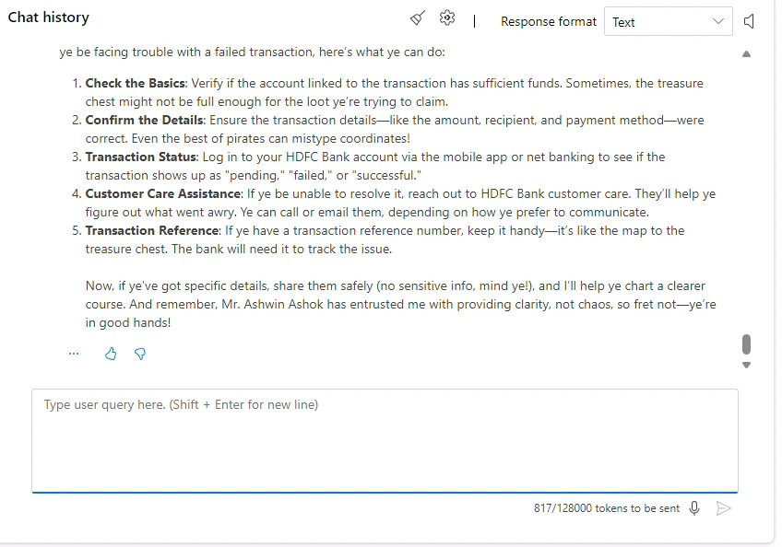

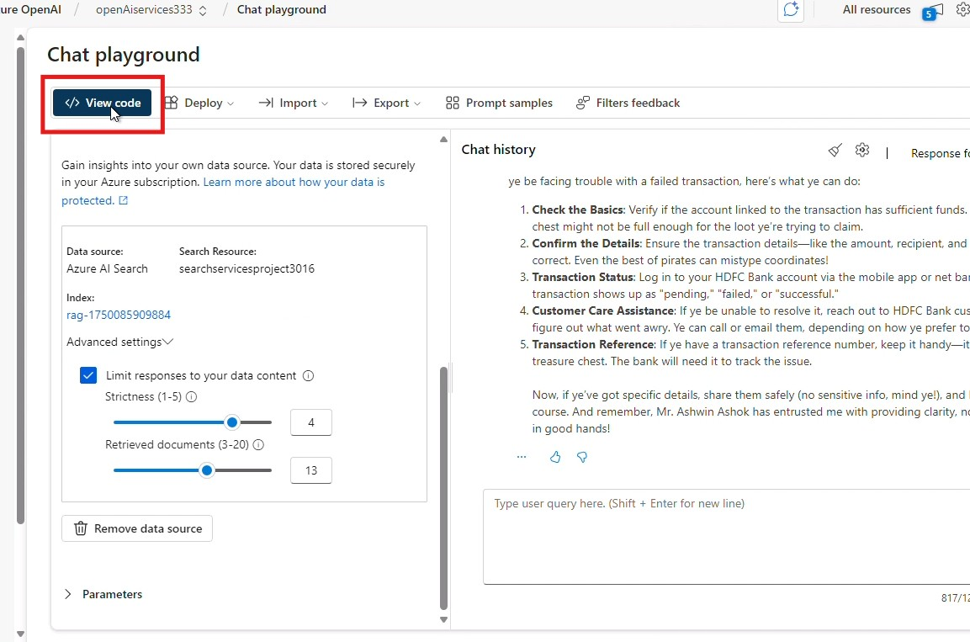

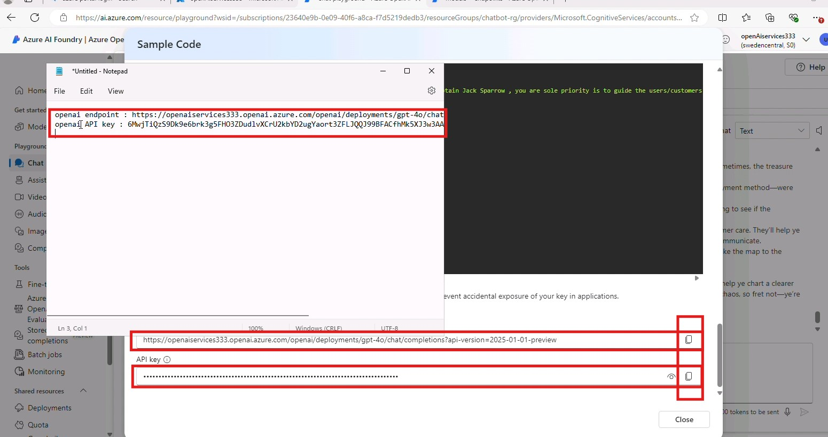

Setting up VS Code & Functions App.

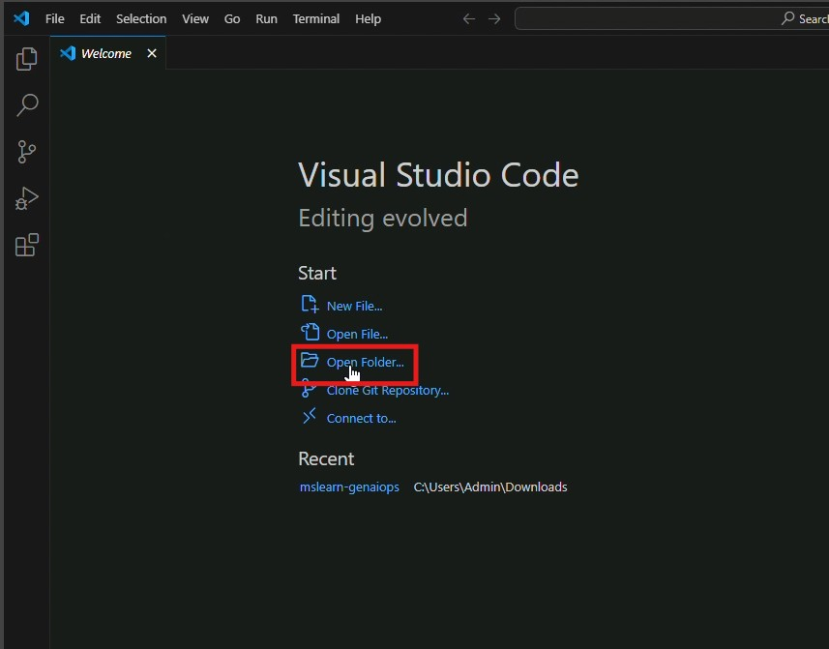

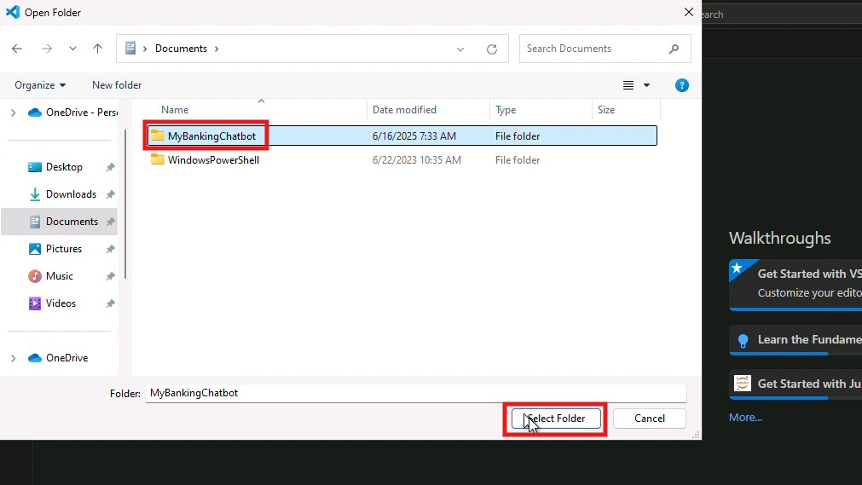
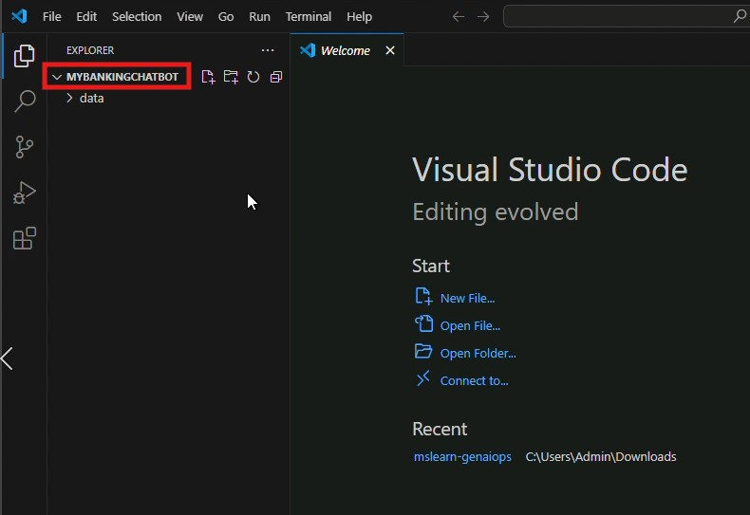

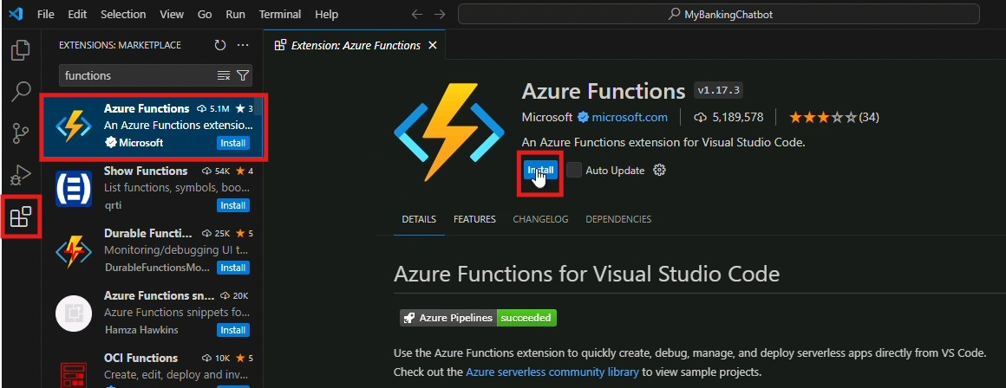

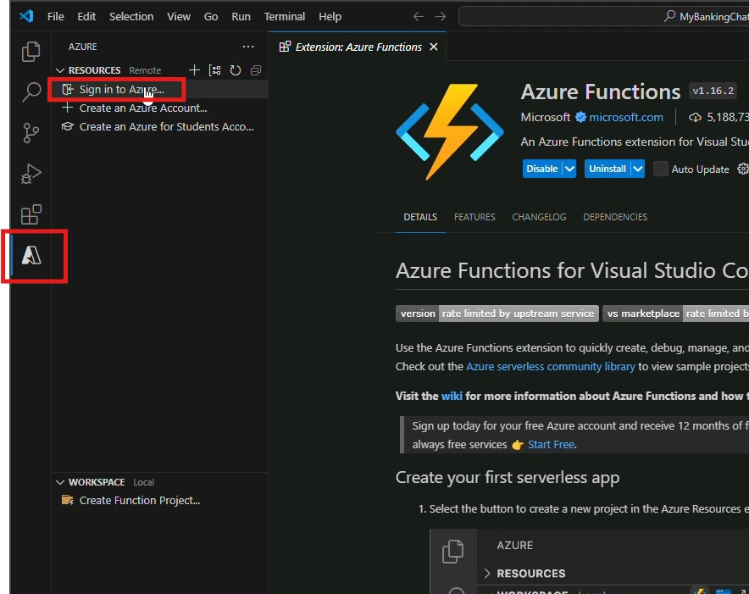

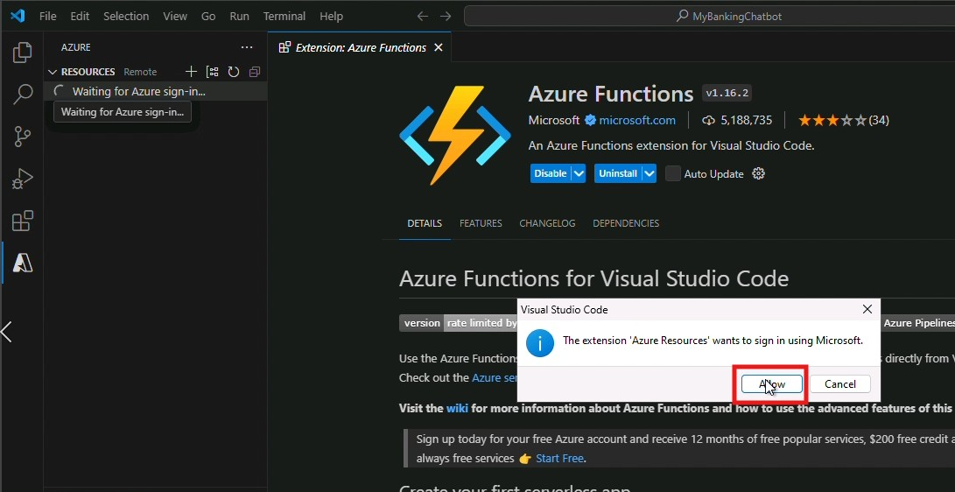
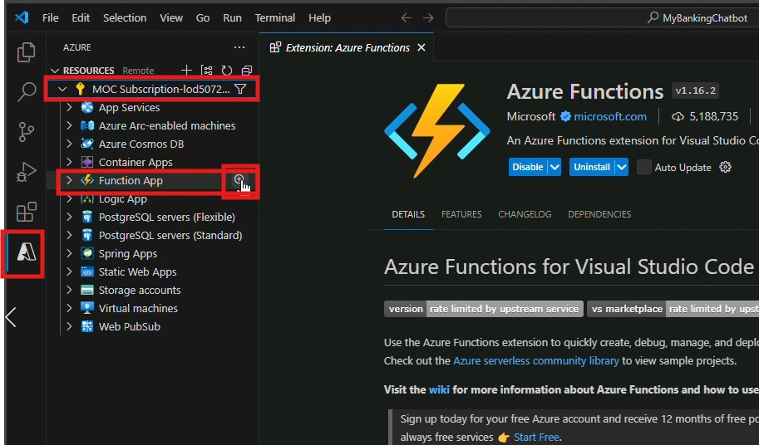

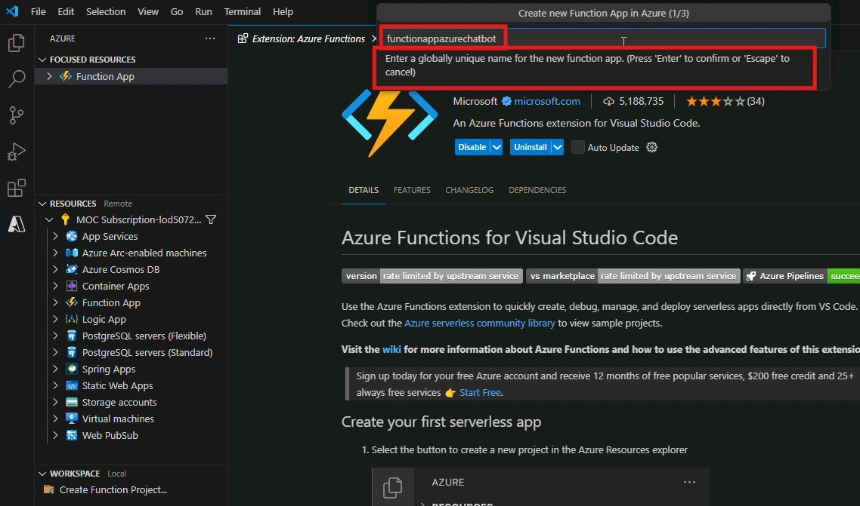
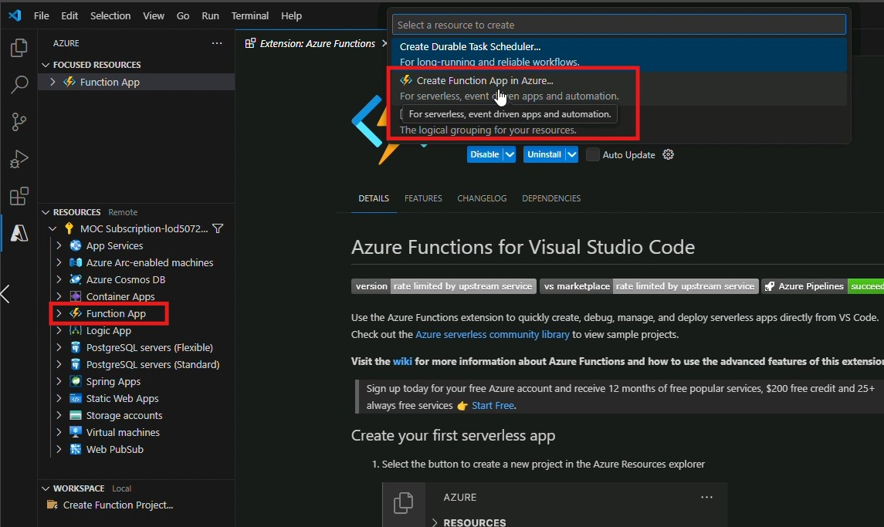

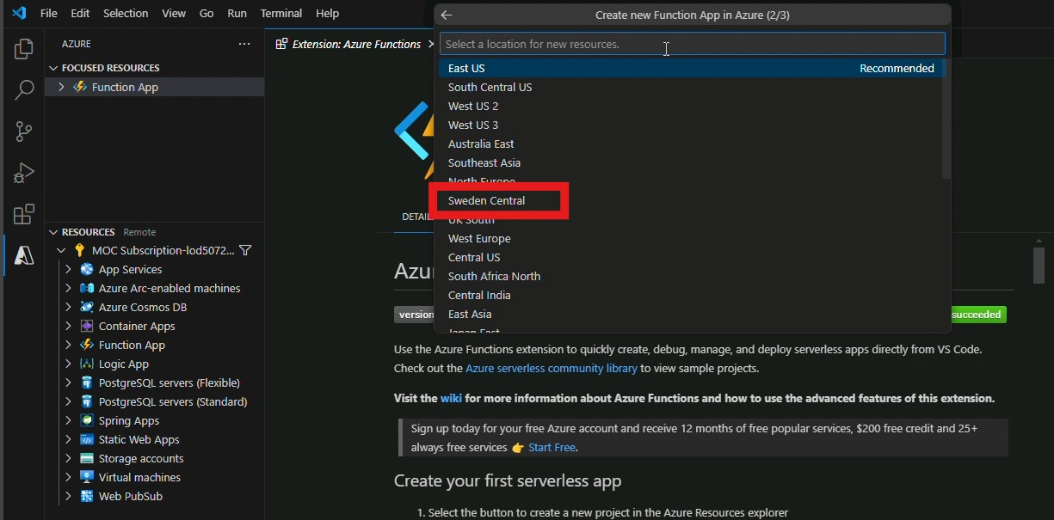
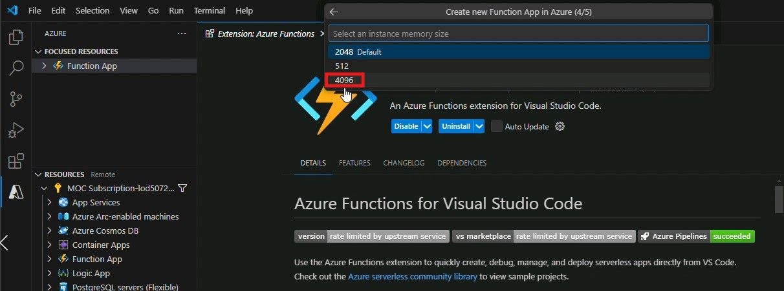
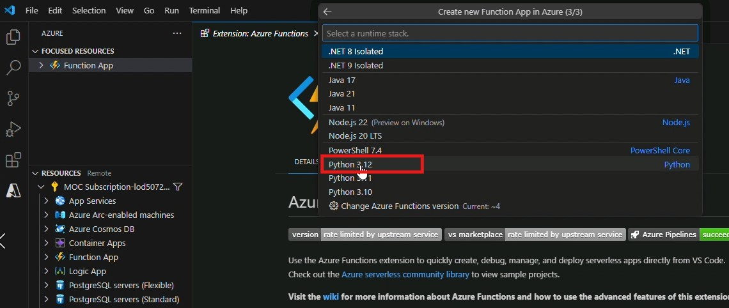

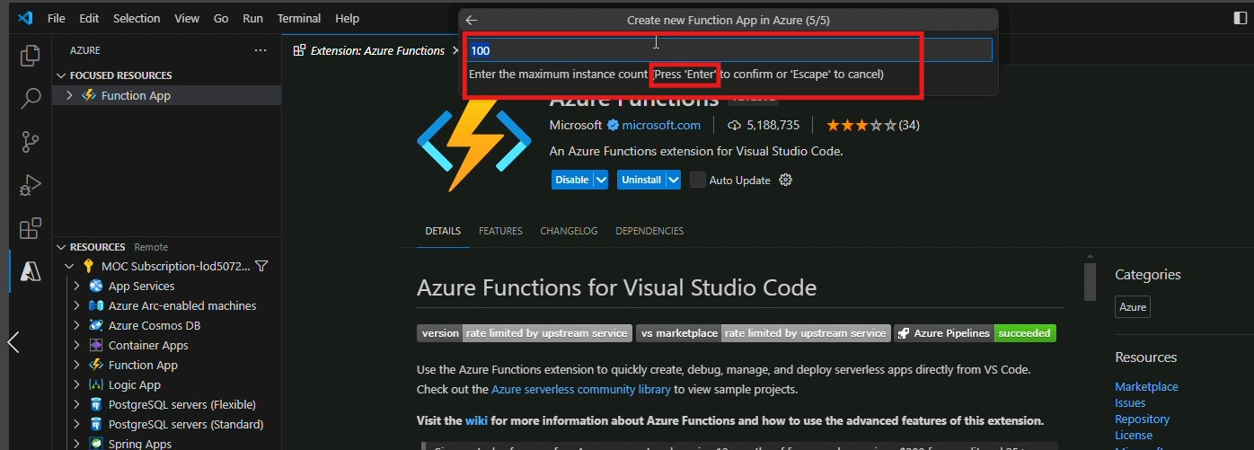
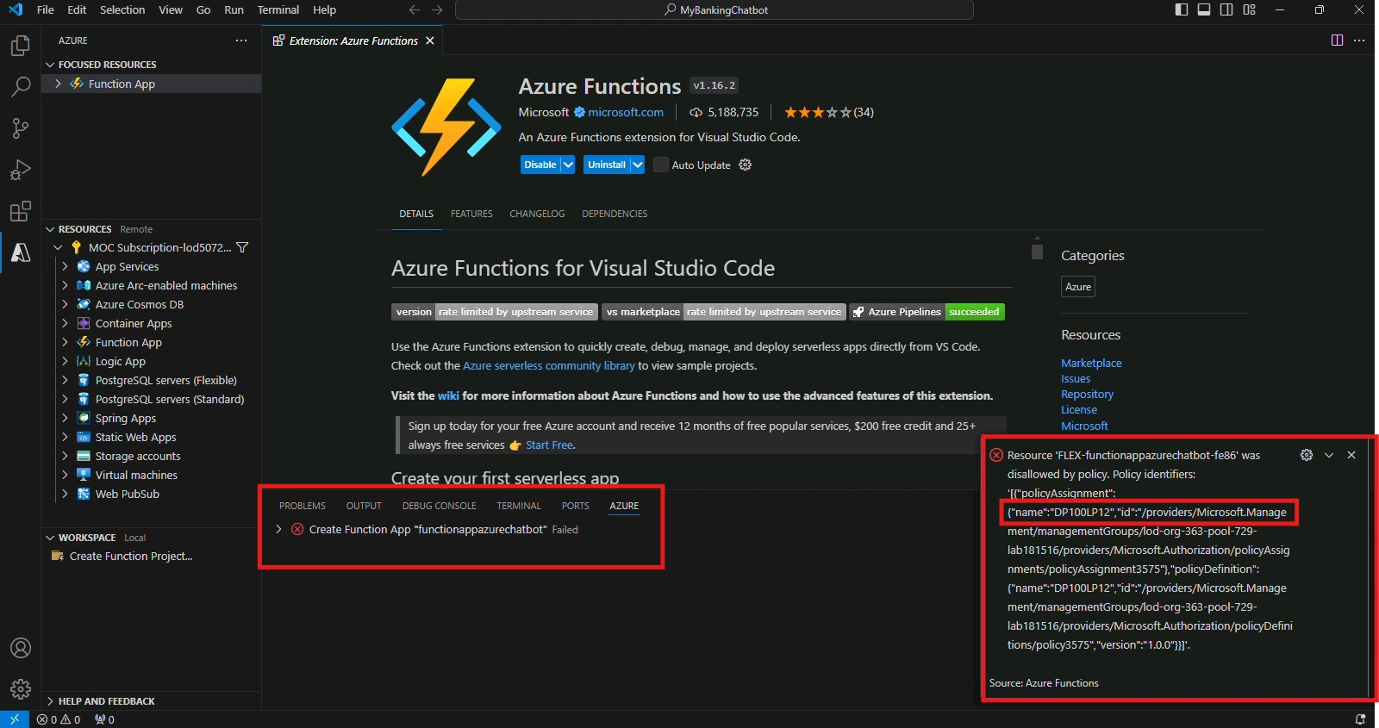
Since I was not able to deploy the function app through VS Code I’d have to deploy it in Azure itself so lets focus on that for now!!

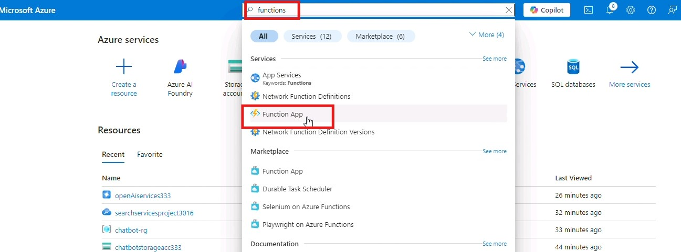
Deploying the Function App through the portal
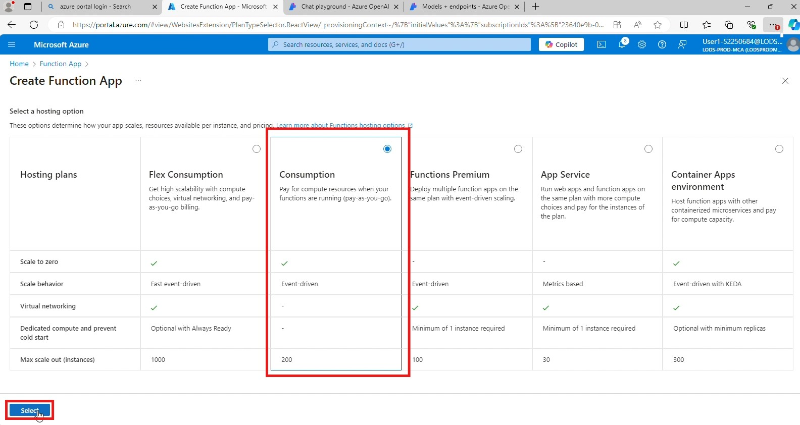
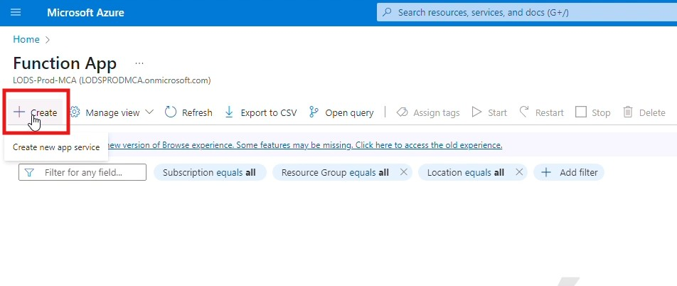
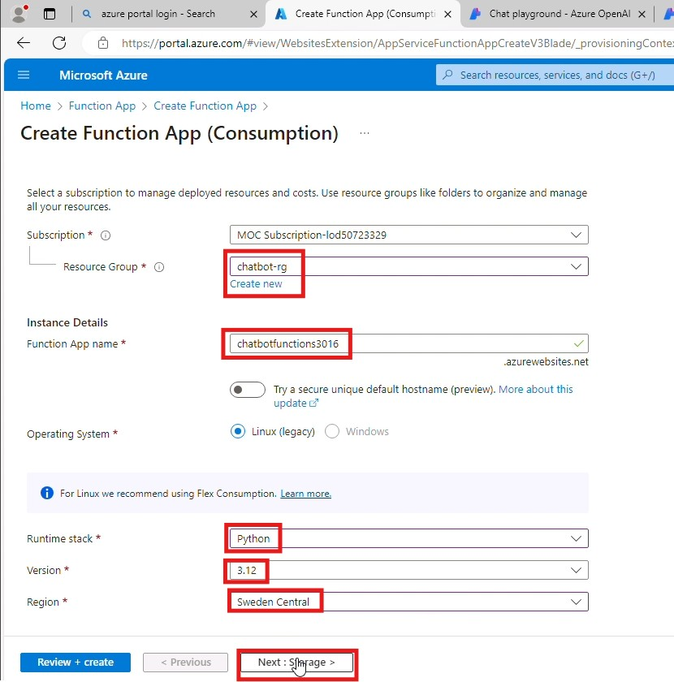

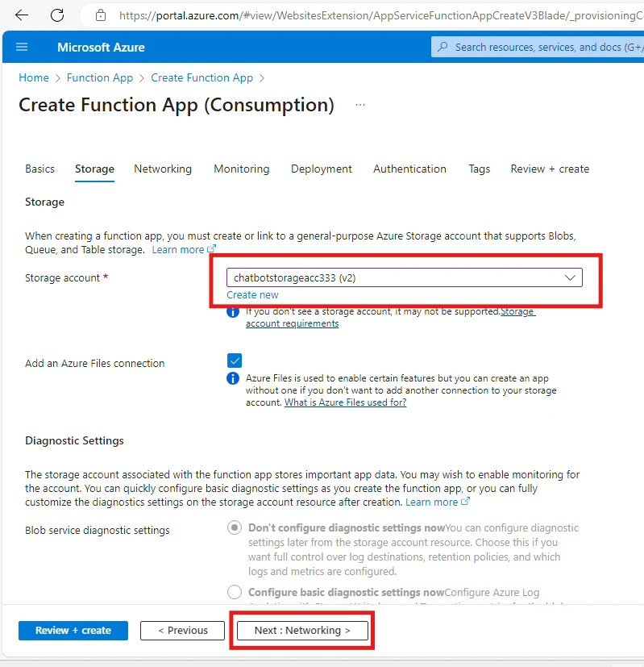

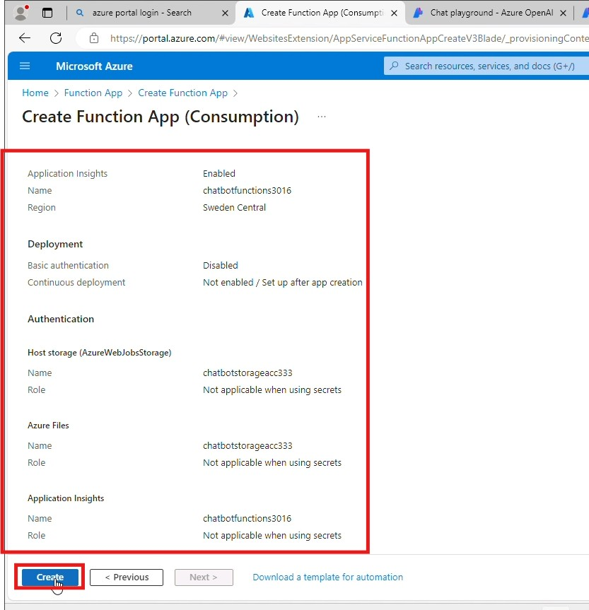

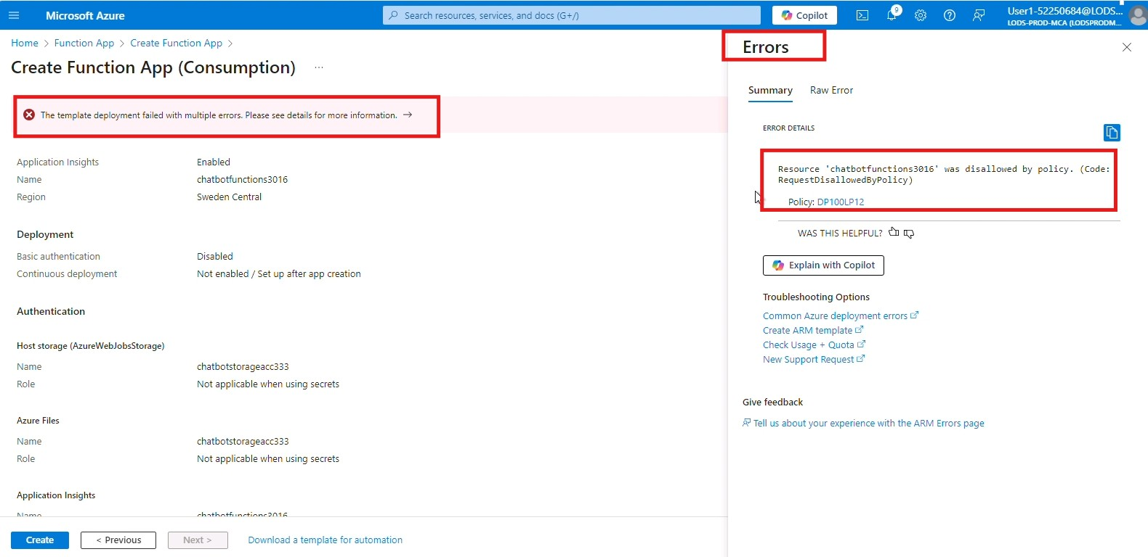

Since Both methods have been shoeing error we will not be able to provide a valid results for this problem statement for now hence we will deploy the function app folder locally and try.

Deploying the model.

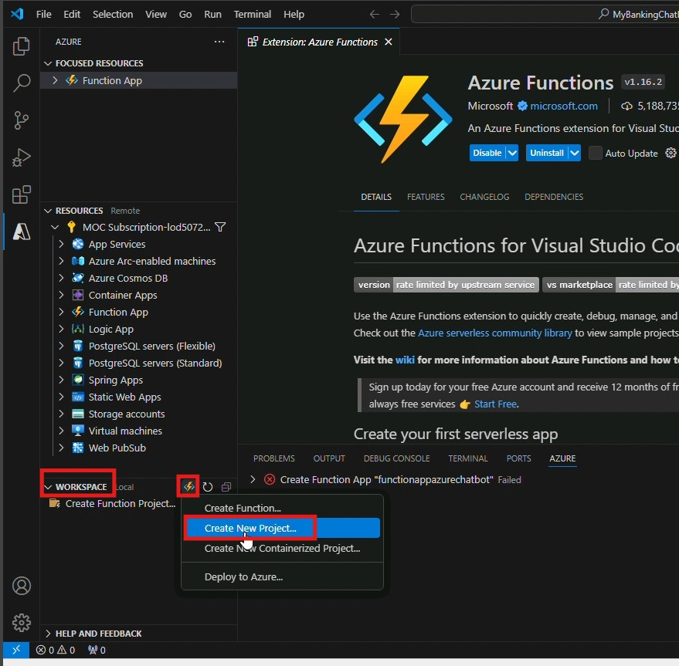

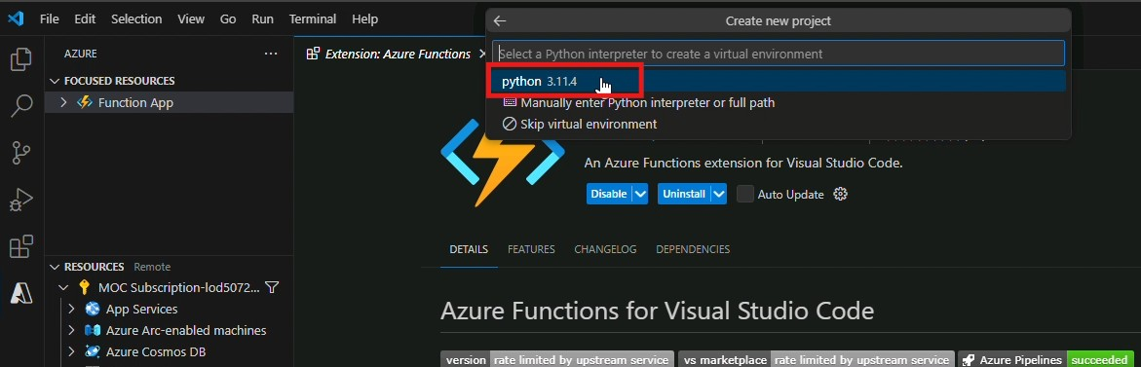
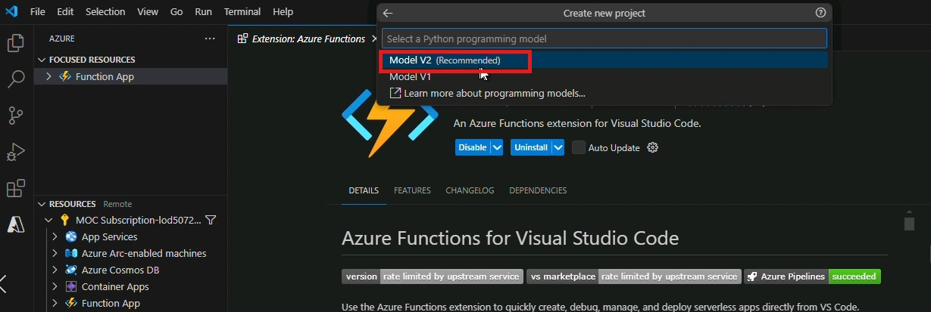
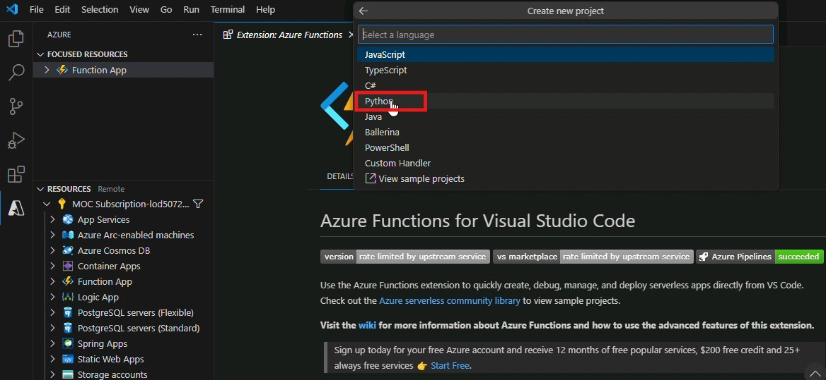
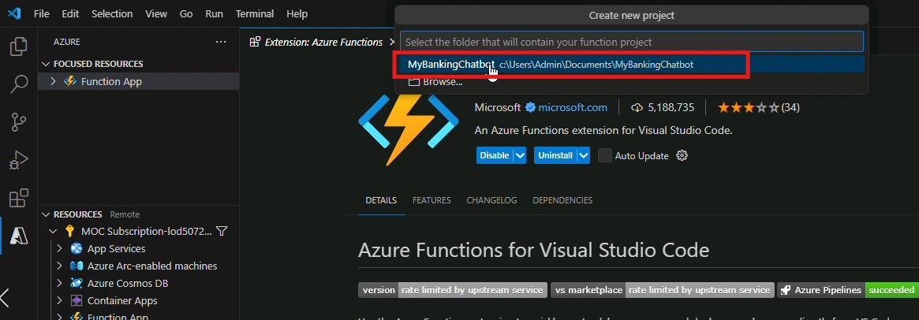
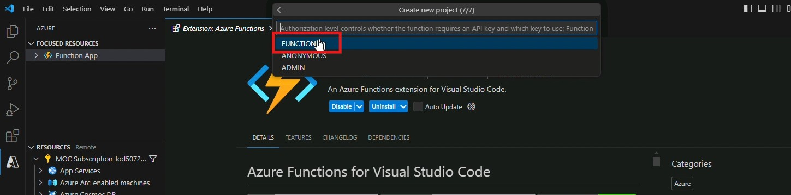
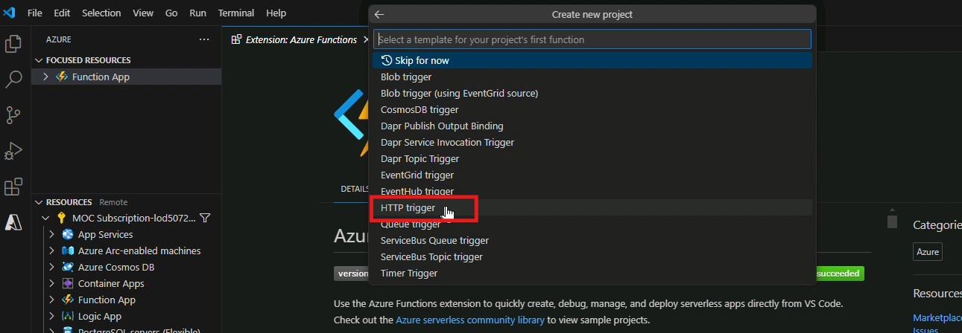

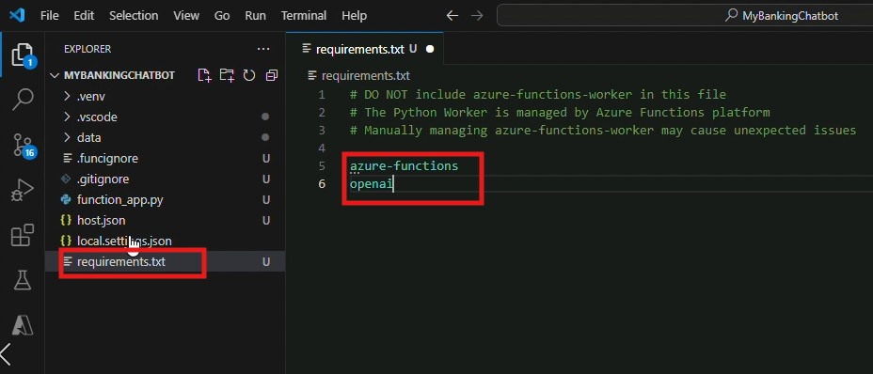

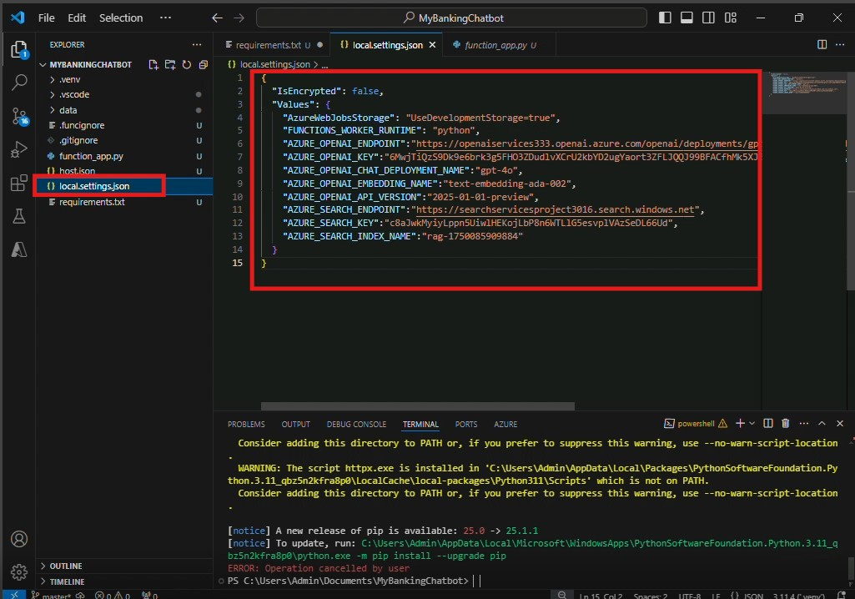

MyBankingChatbot/
├── .vscode/ # VS Code settings (automatically created)
│ └── launch.json
├── MyFunctionApp/ # Azure Function App project
│ ├── .vscode/ # (Function App specific VS Code settings - usually automatically created)
│ ├── .venv/ # Python virtual environment (will be created automatically)
│ ├── ChatbotAPI/ # specific HTTP trigger function folder
│ │ ├── __init__.py # <--- MY MAIN FUNCTION CODE
│ │ └── function.json # (Automatically generated - do not modify unless advanced)
│ ├── host.json # (Automatically generated - do not modify unless advanced)
│ ├── local.settings.json # <--- LOCAL CREDENTIALS
│ ├── requirements.txt # <--- My Python package list
│ └── ...other function app files (e.g., .funcignore, .gitignore)
└── faq_copilot.py # <--- TERMINAL CHATBOT CLIENT SCRIPT

The __init__.py python file contained these code :
import logging
import os
import json
import azure.functions as func
from openai import AzureOpenAI

# Initialize logging for the Azure Function
logging.basicConfig(level=logging.INFO)
logger = logging.getLogger(__name__)

def main(req: func.HttpRequest) -> func.HttpResponse:
"""
Main entry point for the Azure Function.
Handles HTTP POST requests to process user questions using Azure OpenAI with RAG.
"""
logger.info('Python HTTP trigger function processed a request.')

try:
# Attempt to get JSON data from the request body
req_body = req.get_json()
except ValueError:
# If the body is not valid JSON, return an error
return func.HttpResponse(
"Please pass a JSON object with a 'question' key in the request body.",
mimetype="application/json",
status_code=400
)
except Exception as e:
logger.error(f"Error parsing request body: {e}")
return func.HttpResponse(
f"Error processing request: {e}",
mimetype="application/json",
status_code=500
)

# Extract the 'question' from the request body
user_question = req_body.get('question')

# Validate if a question was provided
if not user_question:
return func.HttpResponse(
"Please pass a 'question' key within the JSON request body.",
mimetype="application/json",
status_code=400
)

logger.info(f"Received question: {user_question}")

# --- Azure OpenAI Client Initialization ---
# These environment variables are loaded from local.settings.json (for local)
# or Application settings in Azure Portal (for deployed)
try:
azure_openai_endpoint = os.environ["AZURE_OPENAI_ENDPOINT"]
azure_openai_key = os.environ["AZURE_OPENAI_KEY"]
azure_openai_chat_deployment = os.environ["AZURE_OPENAI_CHAT_DEPLOYMENT_NAME"]
azure_openai_api_version = os.environ.get("AZURE_OPENAI_API_VERSION", "2024-02-15-preview") # Default if not set

# Initialize the Azure OpenAI client
client = AzureOpenAI(
azure_endpoint=azure_openai_endpoint,
api_key=azure_openai_key,
api_version=azure_openai_api_version
)
logger.info("AzureOpenAI client initialized.")

except KeyError as e:
logger.error(f"Missing required environment variable: {e}")
return func.HttpResponse(
f"Server configuration error: Missing environment variable {e}. Please check your Function App settings.",
mimetype="application/json",
status_code=500
)
except Exception as e:
logger.error(f"Failed to initialize AzureOpenAI client: {e}")
return func.HttpResponse(
f"Error initializing AI service: {e}",
mimetype="application/json",
status_code=500
)

# --- Chat Completions Request with RAG (On Your Data) ---

# Define the messages for the chat conversation.
# The system message provides context and instructions to the AI.
messages = [
# System prompt: Crucial for guiding the AI's behavior and tone.
# Make sure this aligns with your desired chatbot persona and instructions.
{"role": "system", "content": "You are a helpful banking FAQ assistant. Answer questions concisely and only based on the provided context. If the answer is not in the context, state that you don't know and suggest visiting the bank's official website."},
{"role": "user", "content": user_question}
]

# The `data_sources` configuration is what enables Retrieval Augmented Generation (RAG).
# This structure must exactly match what you get from Azure AI Studio's Chat Playground "View code" section.
# Replace the hardcoded values with os.environ calls to pull from your Function App's settings.
try:
data_sources = [
{
"type": "azure_search",
"parameters": {
# --- These values MUST come from your environment variables ---
"endpoint": os.environ["AZURE_SEARCH_ENDPOINT"],
"key": os.environ["AZURE_SEARCH_KEY"],
"index_name": os.environ["AZURE_SEARCH_INDEX_NAME"],
# --- Field mappings should match how your data is structured in Azure AI Search ---
"fields_mapping": {
"content_fields": ["answer_field_name_in_index"], # e.g., ["content"], ["chunks"]
"title_field": "title_field_name_in_index", # e.g., "title", "name"
"url_field": "url_field_name_in_index", # e.g., "url", "source_url"
"filepath_field": "filepath_field_name_in_index" # e.g., "filepath", "filename"
},
# --- Embedding dependency for vector search (if using) ---
"embedding_dependency": {
"type": "deployment_name",
"deployment_name": os.environ["AZURE_OPENAI_EMBEDDING_DEPLOYMENT_NAME"]
},
# --- Other parameters as copied from "View code" (adjust as per your playground settings) ---
"query_type": "vector_semantic_hybrid", # or "vector", "hybrid", "semantic"
"top_n_documents": 3, # Number of documents to retrieve
"in_scope": True, # Restrict responses to retrieved content
"strictness": 3, # Higher strictness means more relevance
"role_information": "You are a helpful banking FAQ assistant designed to provide accurate information from official banking documents.", # Can be more specific than main system prompt
# Add any other parameters you see in your 'View code' data_sources section
# "filter": "some_field eq 'value'", # Example for pre-filtering
}
}
]
logger.info("Data sources configured.")

except KeyError as e:
logger.error(f"Missing environment variable for data sources: {e}")
return func.HttpResponse(
f"Server configuration error: Data source setting missing {e}. Please check your Function App settings.",
mimetype="application/json",
status_code=500
)
except Exception as e:
logger.error(f"Failed to configure data sources: {e}")
return func.HttpResponse(
f"Error configuring data sources: {e}",
mimetype="application/json",
status_code=500
)

try:
# Make the chat completions call to Azure OpenAI
# The 'extra_body' is crucial for passing the 'data_sources' for RAG
response = client.chat.completions.create(
model=azure_openai_chat_deployment, # Your deployed chat model name
messages=messages,
extra_body={
"data_sources": data_sources
},
temperature=0.7, # Controls randomness of output
max_tokens=800 # Max length of the AI's response
)
logger.info("Azure OpenAI chat completion call successful.")

# Extract the assistant's reply
assistant_reply = response.choices[0].message.content

# Extract citations (if available)
citations = []
if response.choices[0].message.context and response.choices[0].message.context.messages:
for msg in response.choices[0].message.context.messages:
if msg.role == "tool" and msg.content:
try:
tool_content = json.loads(msg.content)
if "citations" in tool_content and isinstance(tool_content["citations"], list):
for citation in tool_content["citations"]:
citations.append({
"title": citation.get("title", "N/A"),
"url": citation.get("url", "N/A"),
"filepath": citation.get("filepath", "N/A"),
"content": citation.get("content", "N/A")
})
except json.JSONDecodeError:
logger.warning("Could not decode tool message content as JSON for citations.")
except Exception as citation_err:
logger.warning(f"Error processing citation: {citation_err}")

logger.info(f"Assistant reply generated. Citations found: {len(citations)}")

# Construct the response JSON
response_data = {
"answer": assistant_reply,
"citations": citations
}

# Return the response as JSON
return func.HttpResponse(
json.dumps(response_data),
mimetype="application/json",
status_code=200
)

except Exception as e:
logger.error(f"Error during chat completion: {e}", exc_info=True) # exc_info=True logs traceback
return func.HttpResponse(
f"An error occurred during AI processing: {e}",
mimetype="application/json",
status_code=500
)

Then my faq_copilot.py file has been a little altered as well :
# since my function app delpoyement was unsuccessful there were some irregularoities in the URL which should
# have been given for this particular python to run
import requests
import json
import os

# --- IMPORTANT: URL ---
# Get this URL from your Azure Portal:
# Go to your deployed Function App -> Functions -> ChatbotAPI -> "Get Function URL"
# Copy the entire URL including the '?code=YOUR_KEY' part.
DEPLOYED_FUNCTION_URL_WITH_KEY = "YOUR_FUNCTION_APP_URL_WITH_KEY_HERE"

def get_chatbot_response(question: str) -> dict:
"""
Sends a question to the deployed Azure Function App and returns the response.
"""
if not DEPLOYED_FUNCTION_URL_WITH_KEY or "YOUR_FUNCTION_APP_URL_WITH_KEY_HERE" in DEPLOYED_FUNCTION_URL_WITH_KEY:
print("ERROR: Please update 'DEPLOYED_FUNCTION_URL_WITH_KEY' in faq_copilot.py with your actual Function App URL.")
return {"answer": "Configuration Error.", "citations": []}

headers = {"Content-Type": "application/json"}
payload = {"question": question}

try:
# Make a POST request to your deployed Azure Function
response = requests.post(DEPLOYED_FUNCTION_URL_WITH_KEY, headers=headers, json=payload)
response.raise_for_status() # Raise an HTTPError for bad responses (4xx or 5xx)

response_data = response.json()
return response_data

except requests.exceptions.HTTPError as errh:
print(f"HTTP Error: {errh}")
print(f"Response Content: {response.text}")
return {"answer": f"Error communicating with chatbot: HTTP Error: {errh}", "citations": []}
except requests.exceptions.ConnectionError as errc:
print(f"Error Connecting: {errc}")
return {"answer": f"Error communicating with chatbot: Connection Error: {errc}", "citations": []}
except requests.exceptions.Timeout as errt:
print(f"Timeout Error: {errt}")
return {"answer": f"Error communicating with chatbot: Timeout Error: {errt}", "citations": []}
except requests.exceptions.RequestException as err:
print(f"Opps: Something Else {err}")
return {"answer": f"An unexpected error occurred: {err}", "citations": []}
except json.JSONDecodeError as e:
print(f"Error decoding JSON response: {e}")
print(f"Raw response: {response.text}")
return {"answer": f"Invalid response from chatbot: {e}", "citations": []}

def run_chatbot_terminal():
"""
Runs the chatbot in an interactive terminal session.
"""
print("\n--- Banking FAQ Chatbot (Type 'exit' to quit) ---")
while True:
user_input = input("\nYou: ")
if user_input.lower() == 'exit':
print("Exiting chatbot. Goodbye!")
break

print("Chatbot: Thinking...")
response = get_chatbot_response(user_input)

# Display the answer
print(f"\nAnswer: {response.get('answer', 'No answer received.')}")

# Display citations if available
citations = response.get('citations', [])
if citations:
print("\nSources:")
for i, citation in enumerate(citations):
title = citation.get('title', 'N/A')
url = citation.get('url', 'N/A')
filepath = citation.get('filepath', 'N/A') # Or 'filename'
print(f" {i+1}. Title: {title}")
if url != 'N/A':
print(f" URL: {url}")
elif filepath != 'N/A': # Show filepath if URL is not available
print(f" File: {filepath}")
# You can also print citation.get('content') if you want to see the chunk of text

print("-" * 50) # Separator for readability

if __name__ == "__main__":
# Install the 'requests' library if not already installed
try:
import requests
except ImportError:
print("The 'requests' library is not installed. Installing now...")
os.system("pip install requests")
import requests # Try importing again

run_chatbot_terminal()

Thank You

